**1.ACKNOWLEDGEMENT**

**Acknowledgement:-**

Fifth Semester Project is a major component of Academic Schedule of B.C.A. Hence I worked on **CINE TICKET PRO**.The conceptual Knowledge acquired by Management/ Computer student is best manifested in the project they undergo. The present project gives a perfect vent to my understanding of the practicalities of information of different Educational areas.I express my whole hearted gratitude towards **Sherwood College Of Professional Management** for having given me the opportunity to undergo my project in the field of Website development of great report and allowing me to gain invaluable experience. I express my heart-felt gratitude to **Mr.Sharad Nigam** for supervising me during the project period. I also express my special thanks to all the staff member who gave me their precious time and help me whenever required. I am also grateful to my parents who have always been supportive in giving me correct decision and advice.

I also express my sincere thanks to all the Respondents, without whose help the completion of this project report was not possible

[Student Name]

5th Semester

**2.Preface**

**Preface-**

I am glad to make this project **CINE TICKET PRO** and now I make this project report. In this project report, I include about my project, objective of project, lists of project activities etc.

Doing this project I have a great experience and I get knowledge about boutique system. These all experience and knowledge I am going to share by my project report.

During work on this project I met many technical problems. These technical problems are solved by our Teacher **Mr. Sharad Nigam.** He is very helpful for me in this project so I am very thankful to him.

**Thanking you.**

**3.Project Report**

# 3.1 INTRODUCTION

**3.1.1 BACKGROUND :-**

In the fast changing world, information technology and information management are going to play an important role. We are living in the computer age during past some year .The computer has gaining popularity. Computer revolution found its way into almost every aspect of human life and living. A computer is admirably suited to handle any information and hence is an information processor that is, it can receive data, perform some basic operations on that data and produces results according to a predetermined program.

This Software is used mainly for the multiplex cinema halls for booking the ticket and storing the information of customers.

The CINE TICKET PRO software is so designed as to ease the workload of multiplex cinema hall professionals. The main feature includes ticket booking, movie show details management and client management.

**3.1.2 OBJECTIVE :-**

Today’s world is computer world because most of work is doing with the help of computer. Dependency on computer is behind the few reasons. We cannot easily manage to store large number of data or information single handle. If we will be need some information or data in urgency then we cannot manage in manually these works are very difficult if we cannot use computer.

As this is generic software it can be used by a wide variety of multiplex cinema halls to automate the process of manually maintaining the records related to the subject of maintaining the movie details and customer data.

This software is basically updating the manual CINE TICKET PRO to automated ticket booking. So that organization can manage their record in efficient and organize them.

* The main objective is to automate non computer environment
* To save manpower.
* It will speed the processing of data and transaction.
* It will provide best security features such as provisions of passwords.
* **System Objective:-**

Today’s world is computer world because most of work is doing with the help of computer. Dependency on computer is behind the few reasons. We cannot easily manage to store large number of data or information single handle. If we will be need some information or data in urgency then we cannot manage in manually these works are very difficult if we cannot use computer.

* **System Context:-**

This section clearly depicts the environment and boundaries of the CINE TICKET PRO system and the entities with which it interacts. It helps us see how the system fits into the existing scheme of things. What the system will do by itself.

* **Functional Requirement:-**

This Software must request Username and Password for access to data, after authentication will allow access to the system. The Software must allow input of products data from administrator and secured access.

* **Non-Functional Requirement:-**

In this Software Input error will be returned in red with appropriate message box. System should automatically update after every transaction.

**3.1.3 PURPOSE AND SCOPE**

* **PURPOSE :-**

The purpose of this document is to specify requirements and to give guidelines for the development of above said project. In particular it gives guidelines on how to prepare the above said project.

This document is intended to be a practical guide for people who developing this software.

* **SCOPE :-**

As this is generic software it can be used by a wide variety of multiplex cinema halls to automate the process of manually maintaining the records related to the subject of maintaining the movie details and customer data.

**3.2 SURVEY OF TECHNOLOGIES**

**3.2.1 JAVA PROGRAMMING LANGUAGE :-**

**Java** is general-purpose [computer-programming language](https://en.wikipedia.org/wiki/Programming_language) that is [concurrent](https://en.wikipedia.org/wiki/Concurrent_computing), [class-based](https://en.wikipedia.org/wiki/Class-based_programming), [object-oriented](https://en.wikipedia.org/wiki/Object-oriented_programming), and specifically designed to have as few implementation dependencies as possible. It is intended to let application developers "[write once, run anywhere](https://en.wikipedia.org/wiki/Write_once,_run_anywhere)" (WORA), meaning that [compiled](https://en.wikipedia.org/wiki/Compiler) Java code can run on all platforms that support Java without the need for recompilation. Java applications are typically compiled to [byte code](https://en.wikipedia.org/wiki/Java_bytecode) that can run on any [Java virtual machine](https://en.wikipedia.org/wiki/Java_virtual_machine) (JVM) regardless of [computer architecture](https://en.wikipedia.org/wiki/Computer_architecture). As of 2016, Java is one of the most [popular programming languages in use](https://en.wikipedia.org/wiki/Measuring_programming_language_popularity), particularly for client-server web applications, with a reported 9 million developers. Java was originally developed by [James Gosling](https://en.wikipedia.org/wiki/James_Gosling) at [Sun Microsystems](https://en.wikipedia.org/wiki/Sun_Microsystems)(which has since been [acquired by Oracle Corporation](https://en.wikipedia.org/wiki/Sun_acquisition_by_Oracle)) and released in 1995 as a core component of Sun Microsystems' [Java platform](https://en.wikipedia.org/wiki/Java_(software_platform)). The language derives much of its [syntax](https://en.wikipedia.org/wiki/Syntax_(programming_languages)) from [C](https://en.wikipedia.org/wiki/C_(programming_language)) and [C++](https://en.wikipedia.org/wiki/C%2B%2B), but it has fewer [low-level](https://en.wikipedia.org/wiki/Low-level_programming_language) facilities than either of them.

**3.2.2 MY SQL :-**

My SQL  is an [open-source](https://en.wikipedia.org/wiki/Open-source) [relational database management system](https://en.wikipedia.org/wiki/Relational_database_management_system) (RDBMS). Its name is a combination of "My", the name of co-founder [Michael Widenius](https://en.wikipedia.org/wiki/Michael_Widenius)'s daughter, and "[SQL](https://en.wikipedia.org/wiki/SQL)", the abbreviation for [Structured Query Language](https://en.wikipedia.org/wiki/Structured_Query_Language). The My SQL development project has made its [source code](https://en.wikipedia.org/wiki/Source_code) available under the terms

the [GNU General Public License](https://en.wikipedia.org/wiki/GNU_General_Public_License), as well as under a variety of [proprietary](https://en.wikipedia.org/wiki/Proprietary_software) agreements. My SQL was owned and sponsored by a single [for-profit](https://en.wikipedia.org/wiki/Business) firm,the [Swedish](https://en.wikipedia.org/wiki/Sweden) company [MySQLAB](https://en.wikipedia.org/wiki/MySQL_AB" \o "MySQL AB),no owned by [Oracle Corporation](https://en.wikipedia.org/wiki/Oracle_Corporation).

For proprietary use, several paid editions are available, and offer additional functionality.

**3.3 REQUIREMENTS & ANALYSIS**

**3.3.1 PROBLEM DEFINITION :-**

Cinema-going is one of the most popular out-of-home cultural activities, affecting a serious of social, economic and cultural phenomena in modern societies. Cinemas are considered to be an integral part of cities and they contribute to the definition of a local geography and identity. They also contribute to the preservation of the collective memory, since they constitute a significant social and cultural practice linked to a specific place, which acts as a common reference or landmark for many individuals. Through this project we present a comprehensive solution for ticket booking in multiplexes. CineTicket Pro, and ticket selling software that is easy to understand, easy to use and offers the simplicity of fast point-and-click service to the employee and admin. This powerful software program is specifically designed for theater owners, to sell tickets. This intuitive visual interface makes day-to-day aspects of selling, exchanging, refunding, and reporting fast and easy for both the user and administrators. Theater Management controls all back-end and front-end functionalities like, movie details, ticket rate and show time, customer information and sales history saved in a database, etc. Theater admin Manages the report details like counter wise report, daily, weekly, monthly report and movie report etc.

**3.3.2 PLANNING AND SCHEDULING :-**

**PERT CHART :-**

A project plan needs to be created to ensure the timely completion of the project. As part of project analysis, we break the project down to a number of stages and use a Gantt chart and PERT chart to describe specific tasks and status.

The Work Breakdown Structure of our proposed system “E-Commerce” is shown below:-

|  |  |  |  |  |
| --- | --- | --- | --- | --- |
| **ID** | **Task Name** | **Duration** | **Start** | **Finish** |
| 1 | Project Initiation | 2 days | 1/7/18 | 2/7/18 |
| 2 | Draft Project Plan | 3 days | 3/7/18 | 6/7/18 |
| 3 | Analysis Phase | 9 days | 7/7/18 | 16/7/18 |
| 4 | Plan User Interviews | 2 days | 17/7/18 | 18/7/18 |
| 5 | Schedule users Interviews | 4 days | 19/7/18 | 22/7/18 |
| 6 | Conducting users Interviews | 2 days | 23/7/18 | 24/7/18 |
| 7 | System Design | 14 days | 25/7/18 | 7/8/18 |
| 8 | Modules Design | 12 days | 8/8/18 | 20/8/18 |
| 9 | Data Structure Design | 3 days | 21/8/18 | 23/8/18 | |
| 10 | User Interface Design | 3 days | 24/8/18 | 26/8/18 | |
| 11 | Coding Phase | 38 days | 27/8/18 | 4/10/18 | |
| 12 | Testing Phase | 8 days | 5/10/18 | 12/10/18 | |
| 13 | Integration Testing | 5 days | 13/10/18 | 17/10/18 | |
| 14 | System Level Testing | 7 days | 18/10/18 | 24/10/18 | |
| 15 | Implementation | 4 days | 25/10/18 | 28/10/18 | |
| 16 | Post-Implementation Review | 2 days | 29/10/18 | 30/10/18 | |

**3.3.3 REQUIRMENTS SPECIFICATION :-**

* **Software Requirements :-**

1. Java/JDK
2. NetBeans
3. MySql
4. SQL YOG

* **Hardware Requirements :-**

1. Pentium IV Processor
2. 512 MB RAM
3. 40 GB HDD
4. Color Monitor
5. Keyboard, Mouse

**3.3.4 PRELIMINARY PRODUCT DESCRIPTION :-**

**MODULE DISCRIPTION :-**

This system will cover mainly two Modules, i.e.

1. User (EMPLOYEE).

2. Theatre (Admin).

* **Theatre Module will cover FOUR Sub modules**,

**a. Adding a Show.**

Theatre can add a show with timing and price of Ticket. This can be seen and booked by User.

**b. Deleting a Show.**

Theatre can delete show if it was performed

**c. Updating Show Details (Its Status).**

Theatre can Update show timing and Price

**d. Each and every Customer Detailing.**

Theatre can see each and every user details, which is registered (booked a ticket before)

* **EMPLOYEE Module will cover FOUR Sub modules,**

1. REGISTER CUSTOMER
2. Booking a Ticket. (House full if there is no Ticket)
3. Booking Details. (Booking Status)
4. Updating CUSTOMER Profile.

**3.3.5 CONCEPTUAL MODELS :-**

**SYSTEM DEVELOPMENT LIFE CYCLE :-**

The System development life cycle (SDLC), or Software development processing [systems engineering](http://en.wikipedia.org/wiki/Systems_engineering), [information systems](http://en.wikipedia.org/wiki/Information_systems) and [software engineering](http://en.wikipedia.org/wiki/Software_engineering), is a process of creating or altering information systems, and the models and [methodologies](http://en.wikipedia.org/wiki/Methodologies) that people use to develop these systems. In software engineering, the SDLC concept underpins many kinds of [software development methodologies](http://en.wikipedia.org/wiki/Software_development_methodologies). These methodologies form the framework for planning and controlling the creation of an information system the [software development process](http://en.wikipedia.org/wiki/Software_development_process).

Broadly, following are the different activities to be considered while defining the system development life cycle for the said project:

* Problem Definition
* System Analysis
* Study of existing system
* Drawback of the existing system
* Proposed system
* System Requirement study
* Data flow analysis
* Feasibility study
* System design
* Input Design (Database & Forms)
* Updating
* Query /Report design
* Administration
* Testing
* Implementation
* Maintenance

**1.SYSTEM ANALYSIS :-**

Systems analysis is the study of sets of interacting entities, including computer systems analysis. This field is closely related to [requirements analysis](http://en.wikipedia.org/wiki/Requirement_analysis) or [operations research](http://en.wikipedia.org/wiki/Operations_research). It is also "an explicit formal inquiry carried out to help someone (referred to as the decision maker) identify a better course of action and make a better decision than he might otherwise have made.

System development can generally be thought of having two major components: systems analysis and systems design. In System Analysis more emphasis is given to understanding the details of an existing system or a proposed one and then deciding whether the proposed system is desirable or not and whether the existing system needs improvements. Thus, system analysis is the process of investigating a system, identifying problems, and using the information to recommend improvement to the system.

**1.2 SYSTEM DESIGN :-**

Systems design is the process of defining the architecture, components, modules, interfaces, and [data](http://en.wikipedia.org/wiki/Data) for a [system](http://en.wikipedia.org/wiki/System) to satisfy specified [requirements](http://en.wikipedia.org/wiki/Requirement). One could see it as the application of [systems theory](http://en.wikipedia.org/wiki/Systems_theory) to [product development](http://en.wikipedia.org/wiki/Product_development). There is some overlap with the disciplines of [systems analysis](http://en.wikipedia.org/wiki/Systems_analysis), [systems architecture](http://en.wikipedia.org/wiki/Systems_architecture) and [systems engineering](http://en.wikipedia.org/wiki/Systems_engineering). If the broader topic of [product development](http://en.wikipedia.org/wiki/Product_development) "blends the perspective of marketing, design, and manufacturing into a single approach to Product development," then design is the act of taking the marketing information and creating the design of the product to be manufactured. Systems design is therefore the process of defining and developing [systems](http://en.wikipedia.org/wiki/System) to satisfy specified [requirements](http://en.wikipedia.org/wiki/Requirement) of the user. Until the 1990s systems design had a crucial and respected role in the [data processing](http://en.wikipedia.org/wiki/Data_processing) industry. In the 1990s [standardization](http://en.wikipedia.org/wiki/Standardization) of hardware and software resulted in the ability to build [modular](http://en.wikipedia.org/wiki/Modularity_(programming)) systems. The increasing importance of software running on generic platforms has enhanced the discipline of [software engineering](http://en.wikipedia.org/wiki/Software_engineering).

[Object-oriented analysis and design](http://en.wikipedia.org/wiki/Object-oriented_analysis_and_design) methods are becoming the most widely used methods for computer systems design. The [UML](http://en.wikipedia.org/wiki/Unified_Modeling_Language) has become the standard language in object-oriented analysis and design. It is widely used for modeling software systems and is increasingly used for high designing non-software systems and organizations.

**ENTITY RELATION DIAGRAMS :-**

The Entity Relation Model or Entity Relation Diagram (ERD) is a data model or diagram for high-level description of conceptual data model, and it provides a graphical notation for representing such data models in the form of entity relationship diagrams. Such models are typically used in the first stage of Management information system design; they are used for example, to describe information needs and/ or the type of information that is to be stored in the Database during the requirement analysis. The data modeling technique, however, can be used to describe any ontology (i.e. an overview and classification of used term and their relationships) for a certain universe of discourse (i.e. area of interest).

In the case of design a Management Information System that is based on a database, the conceptual data model is, a later stage( usually called logical design), mapped to a logical data model such as, relational data model; this is turn in mapped to a physical model during physical design. Note that sometimes, both of the phases are referred a “physical design”. There are number of convention for entity-relation diagrams (ERDs). The classical notation is describe in the remainder of this article, and mainly related to the conceptual modeling. There is a range of notation more typically employed in physical and logical database design.

web

contactno

MAN-AGES

**Theatre**

**Add Movie**

securityques

**Regist-ration**

MAN-AGES

Name

User Theatre

**Book Ticket**

BUY

**User**

Movdate Movname

Seat

MAN-AGES

**User_Image**

ENTITY RELATIONSHIP DIAGRAM

**DATA FLOW DIAGRAM :-**

The data flow diagram shows the flow of data within any system. It is an important tool for designing phase of software engineering. Larry Constantine first developed it. It represents graphical view of flow of data. It’s also known as BUBBLE CHART. The purpose of DFD is major transformation that will become in system design symbols used in DFD.

In the DFD, four symbols are used and they are as follows.

1. A square defines a source (originator) or destination of system data.
2. An arrow identifies data flow-data in motion. It is 2a pipeline through which information flows.
3. A circle or a “bubble “(Some people use an oval bubble) represents a process that transfers informing data flows into outgoing data flows.
4. An open rectangle is a data store-data at rest, or a temporary

Repository of data.

**Context Level Data Flow Diagram :-**

This level shows the overall context of the system and its operating environment and shows the whole system as just one process. Online book store is shown as one process in the context diagram; which is also known as zero level DFD, shown below. The context diagram plays important role in understanding the system and determining the boundaries. The main process can be broken into sub-processes and system can be studied with more detail; this is where 1st level DFD comes into play.

EMPLOYEE

COUSTOMER

Request

ADMIN

Request fulfill

Zero Level Data Flow Diagram

**First Level DFD :-**

This level (level 1) shows all processes at the first level of numbering, data stores, external entities and the data flows between them. The purpose of this level is to show the major high-level processes of the system and their interrelation. A process model will have one, and only one, level-1 diagram. A level-1 diagram must be balanced with its parent context level diagram, i.e. there must be the same external entities and the same data flows, these can be broken down to more detail in the level 1

ADD/UPDATE/DELETE MOVIE

ADD/UPDATE CUSTOMER INFORMATION

ADMIN/EMPLOYEE

TICKET BOOKING AND

REPORT

ADD/UPDATE DELETE EMPLOYEE DETAILS

ONE LEVEL DATA FLOW DIAGRAM

**ScreenShot Of Data Table:-**

**THEATRE REGISTRATION:-**

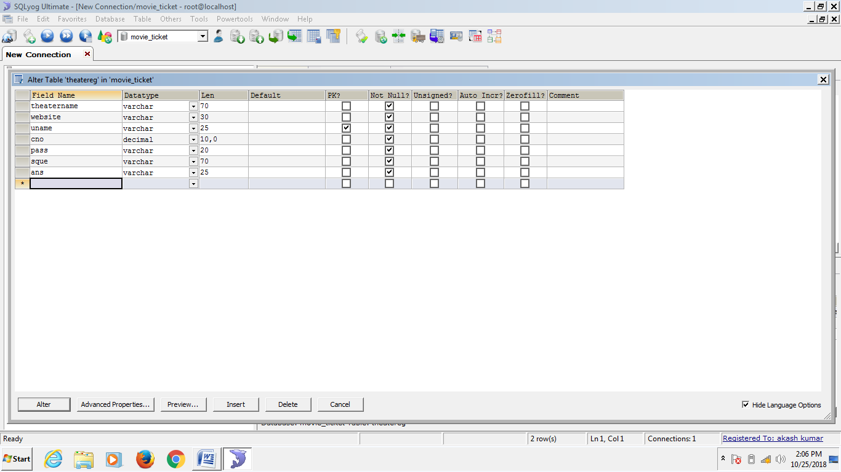

**USER REGISTRATION:-**

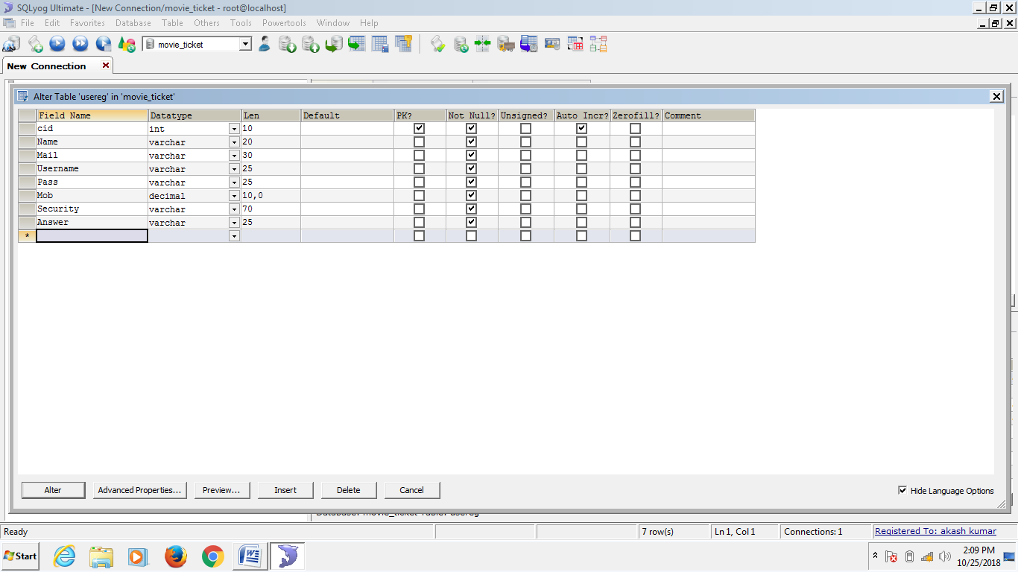

**ADD MOVIE:-**

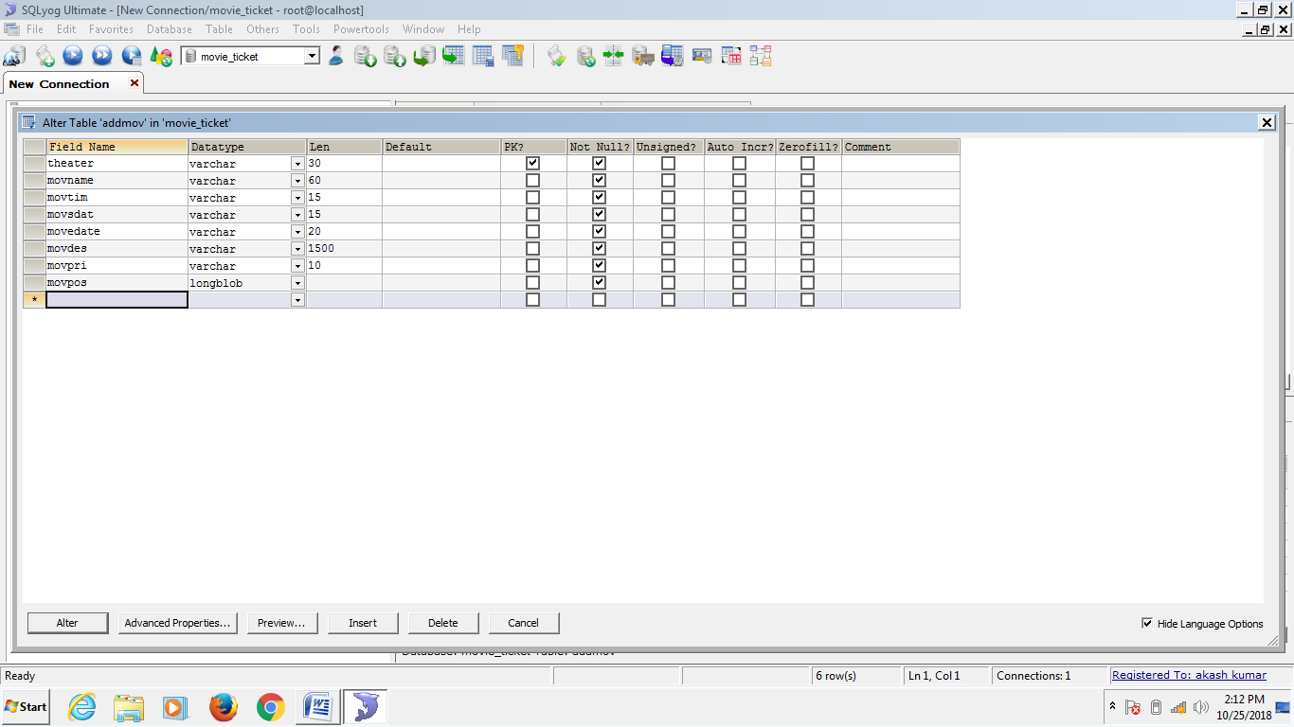

**BOOK TICKET:-**

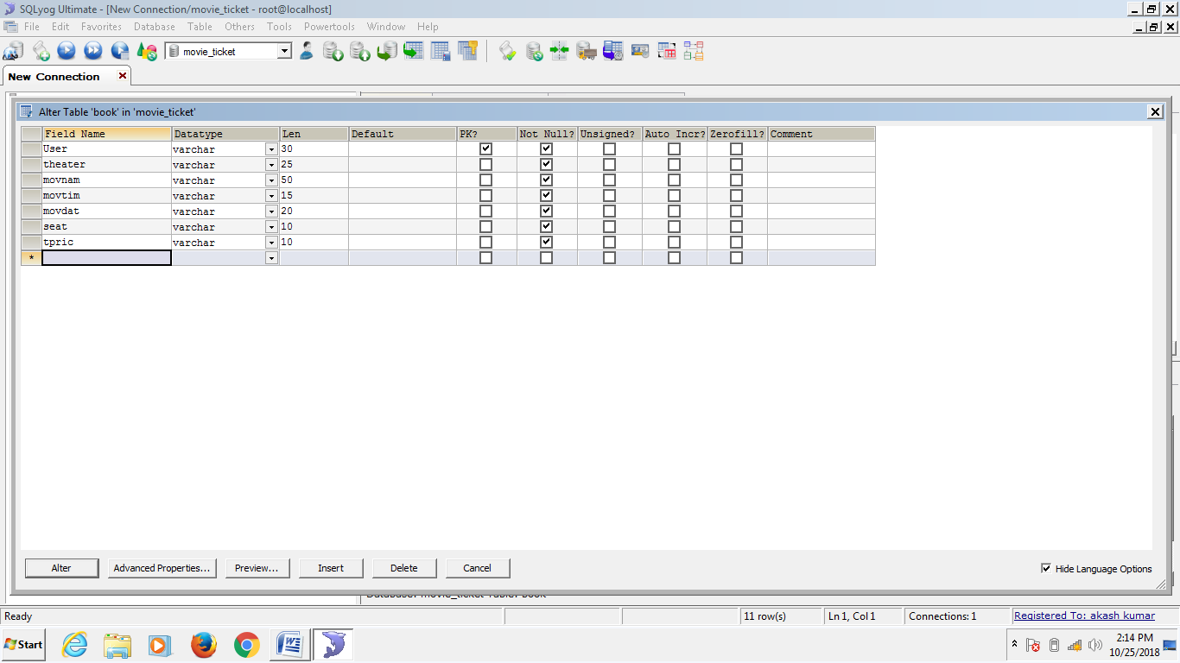

**USER IMAGE:-**

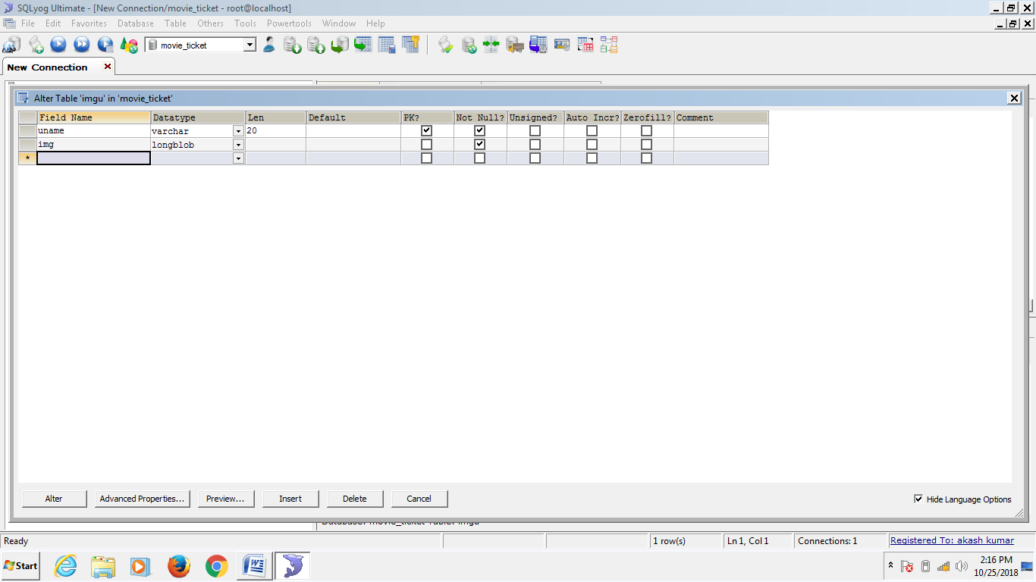

**Data Tables:-**

**THEATRE REGISTRATION :-**

|  |  |  |  |
| --- | --- | --- | --- |
| Name Column | Data Type | Constraints | Size |
| Theatername | Varchar | Not Null | 70 |
| Website | Varchar | Not Null | 30 |
| Username | Varchar | Primary Key | 25 |
| Contectno. | Decimal | Not Null | 10,0 |
| Password | Varchar | Not Null | 20 |
| Securityquestion | Varchar | Not Null | 70 |
| Answer | Varchar | Not Null | 25 |

**USER REGISTRATION :-**

|  |  |  |  |
| --- | --- | --- | --- |
| Name Column | Data Type | Constraints | Size |
| Customerid | Int | Primary key | 10 |
| Name | Varchar | Not Null | 20 |
| Mail | Varchar | Not Null | 30 |
| Username | Varchar | Not Null | 25 |
| Password | Varchar | Not Null | 25 |
| Mobile | Decimal | Not Null | 10,0 |
| Security | Varchar | Not Null | 70 |
| Answer | Varchar | Not Null | 25 |

**ADD MOVIE :-**

|  |  |  |  |
| --- | --- | --- | --- |
| Name Column | Data Type | Constraints | Size |
| Theatre | Varchar | Primary key | 30 |
| Movname | Varchar | Not Null | 60 |
| Movtimming | Varchar | Not Null | 15 |
| Movsdate | Varchar | Not Null | 15 |
| Movedate | Varchar | Not Null | 20 |
| Movdescription | Varchar | Not Null | 1500 |
| Movprice | Varchar | Not Null | 10 |
| Movposter | Longblob | Not Null | 10 |

**BOOK TICKET :-**

|  |  |  |  |
| --- | --- | --- | --- |
| Name Column | Data Type | Constraints | Size |
| User | Varchar | Primary key | 30 |
| Theatre | Varchar | Not Null | 25 |
| Movname | Varchar | Not Null | 50 |
| Movtime | Varchar | Not Null | 15 |
| Movdate | Varchar | Not Null | 20 |
| Seat | Varchar | Not Null | 10 |
| Tprice | Varchar | Not Null | 10 |

**USER IMAGE :-**

|  |  |  |  |
| --- | --- | --- | --- |
| Name Column | Data Type | Constraints | Size |
| Uname | Varchar | Primary key | 20 |
| Image | Longblob | Not Null | 10 |

**3.4 PROJECT CODE**

**Main Window:-**

**Theatre Login Window:-**

if (jTextField8.getText().equals("") || jPasswordField6.getText().equals("")) {

JOptionPane.showMessageDialog(this, "Enter Username and Password");

} else {

try {

dbconnection d = new dbconnection();

d.stmt = d.con.createStatement();

d.rst = d.stmt.executeQuery("SELECT uname,pass,theatername FROM theatereg where uname='" + jTextField8.getText() + "'");

if (d.rst.next()) {

if (jPasswordField6.getText().equals(d.rst.getString(2))) {

Theater t = new Theater();

t.jLabel9.setText(d.rst.getString(3));

t.setVisible(true);

this.dispose();

} else {

JOptionPane.showMessageDialog(this, "Password Incorrect");

}

} else {

JOptionPane.showMessageDialog(this, "Username Incorrect");

}

}

catch (Exception e) {

e.getMessage();

}

}

**Reset:-**

jTextField8.setText("");

jPasswordField6.setText("");

}

**Back:-**

int v = JOptionPane.showConfirmDialog(this, "Are You Sure?", "Confirmation", 0);

if (v == 0) {

jButton11ActionPerformed(evt);

Theater.setVisible(false);

jPanel2.setVisible(true);

jPanel3.setVisible(true);

}

}

**Register Your theatre:-**

**Register:-**

if (jTextField9.getText().equals("") || jPasswordField8.getText().equals("") || jTextField10.getText().equals("") || jComboBox3.getSelectedIndex() == 0 || jTextField13.getText().equals("") || jTextField12.getText().equals("") || jTextField11.getText().equals("")) {

JOptionPane.showMessageDialog(this, "Fill all details to register your theater");

}

else if(!(Text(jTextField9.getText())))

{

JOptionPane.showMessageDialog(this,"invalid Characters");

jTextField9.setText("");

}

else if(!(Email(jTextField10.getText()))){

JOptionPane.showMessageDialog(this,"Invalid Email Id");

jTextField10.setText("");

}

else if(!(PhoneNumber(jTextField12.getText()))){

JOptionPane.showMessageDialog(this,"Invalid Phone");

jTextField12.setText("");

}

else {

try {

String pass = jPasswordField8.getText();

if (pass.equals(jPasswordField7.getText())) {

dbconnection d = new dbconnection();

d.pstmt = d.con.prepareStatement("INSERT INTO theatereg(theatername,website,uname,cno,pass,sque,ans)VALUES (?,?,?,?,?,?,?) ");

d.pstmt.setString(1, jTextField9.getText());

d.pstmt.setString(2, jTextField10.getText());

d.pstmt.setString(3, jTextField13.getText());

d.pstmt.setString(4, jTextField12.getText());

d.pstmt.setString(5, pass);

d.pstmt.setString(6, String.valueOf(jComboBox3.getSelectedItem()));

d.pstmt.setString(7, jTextField11.getText());

int j = d.pstmt.executeUpdate();

if (j > 0) {

JOptionPane.showMessageDialog(this, "Theater Registered");

jButton14ActionPerformed(evt);

}

} else {

JOptionPane.showMessageDialog(this, "Retype the Passwords");

}

}

catch (Exception e) {

e.getMessage();

}

}

}

**Reset:-**

jPasswordField7.setText("");

jPasswordField8.setText("");

jTextField9.setText("");

jTextField10.setText("");

jTextField11.setText("");

jTextField12.setText("");

jTextField13.setText("");

jComboBox3.setSelectedIndex(0);

}

**Back:-**

int v = JOptionPane.showConfirmDialog(this, "Are You Sure?", "Confirmation", 0);

if (v == 0) {

jButton14ActionPerformed(evt);

theatereg.setVisible(false);

jButton11ActionPerformed(evt);

Theater.setVisible(true);

}

}

**Forgot Password:-**

try {

Fpass1.setVisible(true);

Theater.setVisible(false);

dbconnection d = new dbconnection();

d.stmt = d.con.createStatement();

d.rst = d.stmt.executeQuery("SELECT sque FROM theatereg where uname='" + jTextField8.getText() + "'");

if (d.rst.next()) {

jComboBox4.addItem(d.rst.getString(1));

}

} catch (Exception e) {

e.getMessage();

}

}

**Change:-**

try {

dbconnection d = new dbconnection();

d.stmt = d.con.createStatement();

d.rst = d.stmt.executeQuery("Select ans from theatereg where uname='" + jTextField8.getText() + "'");

if (d.rst.next()) {

if (jTextField14.getText().equals(d.rst.getString(1))) {

if (jPasswordField10.getText().equals(jPasswordField9.getText())) {

d.pstmt = d.con.prepareStatement("Update theatereg SET pass='" + jPasswordField10.getText() + "'");

int i = d.pstmt.executeUpdate();

if (i > 0) {

JOptionPane.showMessageDialog(this, "Password Changed");

jButton17ActionPerformed(evt);

}

} else {

JOptionPane.showMessageDialog(this, "Retype the passwords.");

}

} else {

JOptionPane.showMessageDialog(this, "The Answer did not match.");

}

}

}

catch (Exception e) {

e.getMessage();

}

**Reset:-**

jTextField14.setText("");

jPasswordField9.setText("");

jPasswordField10.setText("");

jComboBox4.removeAllItems();

}

**Back:-**

int v = JOptionPane.showConfirmDialog(this, "Are You Sure?", "Confirmation", 0);

if (v == 0) {

jButton17ActionPerformed(evt);

Fpass1.setVisible(false);

jButton11ActionPerformed(evt);

Theater.setVisible(true);

}

}

**Theatre Window:-**

**Add a Show:-**

if (jTextField1.getText().equals("") || jTextField2.getText().equals("") || jTextField5.getText().equals("") || ((JTextField) jDateChooser1.getDateEditor().getUiComponent()).getText().equals("") || ((JTextField) jDateChooser1.getDateEditor().getUiComponent()).getText().equals("") || jTextArea1.getText().equals("") || jTextField3.getText().equals("")) {

JOptionPane.showMessageDialog(this, "Fill all details to add a show");

} else {

try {

dbconnection d = new dbconnection();

d.pstmt = d.con.prepareStatement("INSERT INTO addmov(theater,movname,movtim,movsdat,movedate,movdes,movpri,movpos)VALUES (?,?,?,?,?,?,?,?)");// TODO add your handling code here:

InputStream tg = new FileInputStream(new File(jTextField2.getText()));

d.pstmt.setString(1, jLabel9.getText());

d.pstmt.setString(2, jTextField1.getText());

d.pstmt.setString(3, String.valueOf(jTextField3.getText()));

d.pstmt.setString(4, ((JTextField) jDateChooser1.getDateEditor().getUiComponent()).getText());

d.pstmt.setString(5, ((JTextField) jDateChooser2.getDateEditor().getUiComponent()).getText());

d.pstmt.setString(6, jTextArea1.getText());

d.pstmt.setString(7, jTextField5.getText());

d.pstmt.setBlob(8, tg);

int i = d.pstmt.executeUpdate();

if (i > 0) {

JOptionPane.showMessageDialog(this, "Movie added successfully");

jTextField1.setText("");

jTextField2.setText("");

jTextField3.setText("");

jDateChooser1.setDate(null);

jDateChooser2.setDate(null);

jTextArea1.setText("");

jTextField5.setText("");

}

} catch (Exception e) {

e.getMessage();

}

}

}

**Delete a Show:-**

**Search a Show:-**

try {

dbconnection d = new dbconnection();

d.stmt = d.con.createStatement();

d.rst = d.stmt.executeQuery("Select * from addmov where movname='" + jTextField4.getText() + "'And theater='" + jLabel9.getText() + "'");

if (d.rst.next()) {

jTextField6.setText(d.rst.getString(3));

jDateChooser3.setDate(d.rst.getDate(4));

jDateChooser4.setDate(d.rst.getDate(5));

} else {

JOptionPane.showMessageDialog(this, "No movie found");

}

} catch (Exception e) {

e.getMessage();

}

}

**Delete a Show:-**

try {

dbconnection d = new dbconnection();

d.pstmt = d.con.prepareStatement("delete from addmov where movname='" + jTextField4.getText() + "'And theater='" + jLabel9.getText() + "'");// TODO add your handling code here:

int j = d.pstmt.executeUpdate();

if (j > 0) {

JOptionPane.showMessageDialog(this, "Show deleted successfully");

jTextField4.setText("");

jTextField6.setText("");

jDateChooser3.setDate(null);

jDateChooser4.setDate(null);

}

} catch (Exception e) {

e.getMessage();

}

}

**Update Show Details:-**

**Search a Show:-**

try {

dbconnection d = new dbconnection();

d.stmt = d.con.createStatement();

d.rst = d.stmt.executeQuery("Select * from addmov where movname='" + jTextField7.getText() + "'And theater='" + jLabel9.getText() + "'");

if (d.rst.next()) {

jTextField7.setEditable(false);

jTextField9.setText(d.rst.getString(3));

jDateChooser5.setDate(d.rst.getDate(4));

jDateChooser6.setDate(d.rst.getDate(5));

jTextArea2.setText(d.rst.getString(6));

jTextField10.setText(d.rst.getString(7));

} else {

JOptionPane.showMessageDialog(this, "No movie found");

}

} catch (Exception e) {

e.getMessage();

}

**Update a Show:-**

if (jTextField9.getText().equals("") || jTextField8.getText().equals("") || jTextField10.getText().equals("") || ((JTextField) jDateChooser5.getDateEditor().getUiComponent()).getText().equals("") || ((JTextField) jDateChooser6.getDateEditor().getUiComponent()).getText().equals("") || jTextArea2.getText().equals("")) {

JOptionPane.showMessageDialog(this, "Fill all details to update the show");

} else {

try {

dbconnection d = new dbconnection();

InputStream t = new FileInputStream(new File(jTextField8.getText()));

d.pstmt = d.con.prepareStatement("Update addmov SET movtim = ?,movsdat = ?,movedate = ?,movdes=?,movpri=?,movpos = ? WHERE movname='" + jTextField7.getText() + "'And theater='" + jLabel9.getText() + "'");

d.pstmt.setString(1, jTextField9.getText());

d.pstmt.setString(2, ((JTextField) jDateChooser5.getDateEditor().getUiComponent()).getText());

d.pstmt.setString(3, ((JTextField) jDateChooser6.getDateEditor().getUiComponent()).getText());

d.pstmt.setString(4, jTextArea2.getText());

d.pstmt.setString(5, jTextField10.getText());

d.pstmt.setBlob(6, t);

int i = d.pstmt.executeUpdate();// TODO add your handling code here:

if (i > 0) {

JOptionPane.showMessageDialog(this, "Show updated successfully");

}

jTextField7.setText("");

jTextField8.setText("");

jTextField9.setText("");

jDateChooser5.setDate(null);

jDateChooser6.setDate(null);

jTextArea2.setText("");

jTextField10.setText("");

} catch (Exception e) {

e.getMessage();

}

}

}

**User Details:-**

try {

UpdShow.setVisible(false);

AddShow.setVisible(false);

Ud.setVisible(true);

DelShow.setVisible(false);

theaterupd.setVisible(false);

DefaultTableModel df = (DefaultTableModel) jTable2.getModel();

df.getDataVector().removeAllElements();

dbconnection d = new dbconnection();

dbconnection db = new dbconnection();

d.stmt = d.con.createStatement();

db.stmt = db.con.createStatement();

d.rst = d.stmt.executeQuery("SELECT DISTINCT User FROM book WHERE theater='" + jLabel9.getText() + "'");

while (d.rst.next()) {

String name = d.rst.getString(1);

db.rst = db.stmt.executeQuery("SELECT Name,Mail,Mob from usereg WHERE Name='" + name + "'");

if(db.rst.next()) {

Object content[] = {db.rst.getString(1), db.rst.getString(2), db.rst.getString(3)};

df.addRow(content);

}

}

}

catch (Exception e) {

e.getMessage();

}

**Update Profile:-**

**Update Profile:-**

if (jTextField12.getText().equals("") || jComboBox1.getSelectedIndex() == 0 || jTextField14.getText().equals("") || jTextField13.getText().equals("")) {

JOptionPane.showMessageDialog(this, "Fill all details to update profile");

} else {

try {

String mail = jTextField12.getText();

String mob = jTextField14.getText();

Object que = jComboBox1.getSelectedItem();

String nque = String.valueOf(que);

String nans = jTextField13.getText();

dbconnection d = new dbconnection();

d.pstmt = d.con.prepareCall("UPDATE theatereg SET website = '" + mail + "',cno = '" + mob + "',sque = '" + nque + "',ans = '" + nans + "' WHERE theatername = '" + jLabel9.getText() + "'");

int j = d.pstmt.executeUpdate();

if (j > 0) {

JOptionPane.showMessageDialog(this, "Profile Updated Succesfully");

jButton10ActionPerformed(evt);

}

}

catch (Exception e) {

e.getMessage();

}

}

}

**Reset Profile:-**

jPasswordField3.setText("");

jTextField12.setText("");

jTextField13.setText("");

jTextField14.setText("");

jComboBox1.setSelectedIndex(0);

}

**Change Password:-**

jPasswordField2.setText("");

jPasswordField4.setText("");

jPasswordField5.setText("");

Cpass.setVisible(true);

theaterupd.setVisible(false);

}

**Change:-**

try {

dbconnection d = new dbconnection();

d.stmt = d.con.createStatement();

d.rst = d.stmt.executeQuery("SELECT pass FROM theatereg where theatername='" + jLabel9.getText() + "'");

if (d.rst.next()) {

if (jPasswordField5.getText().equals(d.rst.getString(1))) {

if (jPasswordField2.getText().equals(jPasswordField4.getText())) {

d.pstmt = d.con.prepareStatement("UPDATE theatereg SET Pass = '" + jPasswordField2.getText() + "' WHERE theatername='" + jLabel9.getText() + "'");

int g = d.pstmt.executeUpdate();

if (g > 0) {

JOptionPane.showMessageDialog(this, "Password Changed");

jPasswordField2.setText("");

jPasswordField4.setText("");

jPasswordField5.setText("");

Cpass.setVisible(false);

}

} else {

JOptionPane.showMessageDialog(this, "Retype the passwords");

}

} else {

JOptionPane.showMessageDialog(this, "Old Password Incorrect");

}

}

} catch (Exception e) {

e.getMessage();

}

**Delete Your Account:-**

int j = JOptionPane.showConfirmDialog(this, "You will no longer access this account", "Warning", 2, 0);

if (j == 0) {

try {

dbconnection d = new dbconnection();

d.pstmt = d.con.prepareStatement("delete FROM theatereg WHERE theatername ='" + jLabel9.getText() + "'");// TODO add your handling code here:

int f = d.pstmt.executeUpdate();

d.pstmt = d.con.prepareStatement("delete FROM addmov WHERE theater ='" + jLabel9.getText() + "'");

int n = d.pstmt.executeUpdate();

if (f > 0 || n > 0) {

JOptionPane.showMessageDialog(this, "Your account deleted successfully");

MovieTicket1 m = new MovieTicket1();

m.setVisible(true);

this.dispose();

}

} catch (Exception e) {

e.getMessage();

}

}

**Sign Out:-**

int j = JOptionPane.showConfirmDialog(this, "Are you sure?", "Confirmation", 0, 2);

if (j == 0)

{

MovieTicket1 m = new MovieTicket1();

m.setVisible(true);

this.dispose();

}

}

**User Login Window:-**

**User Login:-**

if (jTextField1.getText().equals("") || jPasswordField1.getText().equals("")) {

JOptionPane.showMessageDialog(this, "Enter Username and Password");

} else {

try {

dbconnection d = new dbconnection();

d.stmt = d.con.createStatement();

d.rst = d.stmt.executeQuery("Select Username,Pass,Name From usereg where Username='" + jTextField1.getText() + "'");

if (d.rst.next()) {

if (jPasswordField1.getText().equals(d.rst.getString(2))) {

User u = new User();

u.jLabel4.setText(d.rst.getString(3));

u.jLabel5.setText("Not " + d.rst.getString(3) + "");

u.setVisible(true);

this.dispose();

d.rst = d.stmt.executeQuery("Select img from imgu where uname='" + jTextField1.getText() + "'");

if (d.rst.next()) {

im = d.rst.getBytes(1);

}

Image j = new ImageIcon(im).getImage();

Image k = j.getScaledInstance(u.jLabel1.getWidth(), u.jLabel1.getHeight(), Image.SCALE_SMOOTH);

u.jLabel1.setIcon(new ImageIcon(k));

} else {

JOptionPane.showMessageDialog(this, "Password Incorrect");

}

} else {

JOptionPane.showMessageDialog(this, "Username Incorrect");

}

}

catch (Exception e) {

e.getMessage();

}

}

}

**Reset:-**

jTextField1.setText("");

jPasswordField1.setText("");

jLabel19.setIcon(new javax.swing.ImageIcon(getClass().getResource("/images/icons8_Male_User_100px_1.png")));

}

**Back:-**

int v = JOptionPane.showConfirmDialog(this, "Are You Sure?", "Confirmation", 0);

if (v == 0) {

jButton2ActionPerformed(evt);

User.setVisible(false);

jPanel2.setVisible(true);

jPanel3.setVisible(true);

}

}

**Create An Account:-**

**Create:-**

if (jTextField2.getText().equals("") || jPasswordField3.getText().equals("") || jTextField3.getText().equals("") || jComboBox1.getSelectedIndex() == 0 || jTextField4.getText().equals("") || jTextField6.getText().equals("") || jTextField5.getText().equals("")) {

JOptionPane.showMessageDialog(this, "Fill all details to create a profile");

}

else if(!(Email(jTextField3.getText()))){

JOptionPane.showMessageDialog(this,"Invalid Email Id");

jTextField3.setText("");

}

else if(!(PhoneNumber(jTextField5.getText()))){

JOptionPane.showMessageDialog(this,"Invalid Phone");

jTextField5.setText("");

}

else {

try {

String pass = jPasswordField3.getText();

if (pass.equals(jPasswordField2.getText())) {

dbconnection d = new dbconnection();

d.pstmt = d.con.prepareStatement("INSERT INTO usereg(Name,Mail,Username,Pass,Mob,Security,Answer)VALUES(?,?,?,?,?,?,?)");

d.pstmt.setString(1, jTextField2.getText());

d.pstmt.setString(2, jTextField3.getText());

d.pstmt.setString(3, jTextField6.getText());

d.pstmt.setString(4, pass);

d.pstmt.setString(5, jTextField5.getText());

d.pstmt.setString(6, String.valueOf(jComboBox1.getSelectedItem()));

d.pstmt.setString(7, jTextField4.getText());

int j = d.pstmt.executeUpdate();

if (j > 0) {

JOptionPane.showMessageDialog(this, "New User Created");

jButton5ActionPerformed(evt);

}

} else {

JOptionPane.showMessageDialog(this, "Retype the Passwords");

}

} // TODO add your handling code here:

catch (Exception e) {

e.getMessage();

}

}

}

**Reset:-**

jPasswordField2.setText("");

jPasswordField3.setText("");

jTextField2.setText("");// TODO add your handling code here:

jTextField3.setText("");

jTextField4.setText("");

jTextField5.setText("");

jTextField6.setText("");

jComboBox1.setSelectedIndex(0);

}

**Back:-**

int v = JOptionPane.showConfirmDialog(this, "Are You Sure?", "Confirmation", 0);

if (v == 0) {

jButton5ActionPerformed(evt);

Userreg.setVisible(false);

jButton2ActionPerformed(evt);

User.setVisible(true);

}

}

**Forgot Password:-**

try {

Fpass.setVisible(true);

User.setVisible(false);

dbconnection d = new dbconnection();

d.stmt = d.con.createStatement();

d.rst = d.stmt.executeQuery("Select Security from usereg where Username='" + jTextField1.getText() + "'");

if (d.rst.next()) {

jComboBox2.addItem(d.rst.getString(1));

}

} catch (Exception e) {

e.getMessage();

}

**Change:-**

try {

dbconnection d = new dbconnection();

d.stmt = d.con.createStatement();

d.rst = d.stmt.executeQuery("Select Answer from usereg where Username='" + jTextField1.getText() + "'");

if (d.rst.next()) {

if (jTextField7.getText().equals(d.rst.getString(1))) {

String npass = jPasswordField5.getText();

if (npass.equals(jPasswordField4.getText())) {

d.pstmt = d.con.prepareStatement("Update usereg SET Pass='" + npass + "'");

int i = d.pstmt.executeUpdate();

if (i > 0) {

JOptionPane.showMessageDialog(this, "Password Changed");

jButton8ActionPerformed(evt);

}

} else {

JOptionPane.showMessageDialog(this, "Retype the passwords.");

}

} else {

JOptionPane.showMessageDialog(this, "The Answer did not match.");

}

}

}

catch (Exception e) {

e.getMessage();

}

}

**Reset:-**

jTextField7.setText("");

jPasswordField5.setText("");

jPasswordField4.setText("");

jComboBox2.removeAllItems();

}

**Back:-**

int v = JOptionPane.showConfirmDialog(this, "Are You Sure?", "Confirmation", 0);

if (v == 0) {

jButton8ActionPerformed(evt);

Fpass.setVisible(false);

jButton2ActionPerformed(evt);

User.setVisible(true);

}

**Book a Ticket:-**

**About the Movie:-**

try {

String ava = "";

dbconnection d = new dbconnection();

d.stmt = d.con.createStatement();

d.rst = d.stmt.executeQuery("Select movdes,movpos from addmov where movname='" + jComboBox3.getSelectedItem() + "'AND theater='" + jComboBox4.getSelectedItem() + "'");

if (d.rst.next()) {

jLabel27.setText(d.rst.getString(1));

im = d.rst.getBytes(2);

Image j = new ImageIcon(im).getImage();

Image k = j.getScaledInstance(jLabel3.getWidth(), jLabel3.getHeight(), Image.SCALE_SMOOTH);

jLabel3.setIcon(new ImageIcon(k));

}

d.rst = d.stmt.executeQuery("Select distinct theater from addmov where movname='" + jComboBox3.getSelectedItem() + "'");

while (d.rst.next()) {

ava = ava + d.rst.getString(1) + ", ";

jLabel25.setText(ava);

}

About.setVisible(true);

Bookt.setVisible(false);

} catch (Exception e) {

e.getMessage();

}

}

**Confirm Ticket:-**

int i;

ctick.setVisible(true);

Bookt.setVisible(false);

**Booking History:-**

try {

DefaultTableModel mod = (DefaultTableModel) jTable1.getModel();

mod.getDataVector().removeAllElements();

tcd.setVisible(false);

Bookh.setVisible(true);

Userupd.setVisible(false);

Bookt.setVisible(false);

dbconnection d = new dbconnection();

d.stmt = d.con.createStatement();

d.rst = d.stmt.executeQuery("Select * from book where User='" + jLabel4.getText() + "'");

while (d.rst.next()) {

Object content[] = {d.rst.getString(2), d.rst.getString(3), d.rst.getString(4), d.rst.getString(5), d.rst.getString(6), d.rst.getString(7)};

mod.addRow(content);

}

}

catch (Exception e) {

e.getMessage();

}

}

**Update Profile:-**

**Update Profile:-**

if (jTextField2.getText().equals("") || jComboBox1.getSelectedIndex() == 0 || jTextField7.getText().equals("") || jTextField4.getText().equals("") || jTextField3.getText().equals("") || jTextField6.getText().equals("") || jTextField5.getText().equals("")) {

JOptionPane.showMessageDialog(this, "Fill all details to update profile");

} else {

try {

String mail = jTextField3.getText();

String mob = jTextField5.getText();

Object que = jComboBox1.getSelectedItem();

String nque = String.valueOf(que);

String nans = jTextField4.getText();

String cid = jTextField7.getText();

dbconnection d = new dbconnection();

d.pstmt = d.con.prepareCall("UPDATE usereg SET Mail = '" + mail + "',Mob = '" + mob + "',SECURITY = '" + nque + "',Answer = '" + nans + "' WHERE cid = '" + cid + "'");

int j = d.pstmt.executeUpdate();

if (j > 0) {

JOptionPane.showMessageDialog(this, "Profile Updated Succesfully");

jButton5ActionPerformed(evt);

}

}

catch (Exception e) {

e.getMessage();

}

}

}

**Reset profile:-**

jPasswordField3.setText("");

jTextField3.setText("");

jTextField4.setText("");

jTextField5.setText("");

jComboBox1.setSelectedIndex(0);

}

**Change Password:-**

Cpass.setVisible(true);

Userupd.setVisible(false);

jPasswordField2.setText("");

jPasswordField4.setText("");

jPasswordField5.setText("");

}

**Change:-**

try {

dbconnection d = new dbconnection();

d.stmt = d.con.createStatement();

d.rst = d.stmt.executeQuery("SELECT Pass FROM usereg where Name='" + jLabel4.getText() + "'");

if (d.rst.next()) {

if (jPasswordField5.getText().equals(d.rst.getString(1))) {

if (jPasswordField2.getText().equals(jPasswordField4.getText())) {

d.pstmt = d.con.prepareStatement("UPDATE usereg SET Pass = '" + jPasswordField2.getText() + "' WHERE Name='" + jLabel4.getText() + "'");

int g = d.pstmt.executeUpdate();

if (g > 0) {

JOptionPane.showMessageDialog(this, "Password Changed");

jPasswordField2.setText("");

jPasswordField4.setText("");

jPasswordField5.setText("");

Cpass.setVisible(false);

}

} else {

JOptionPane.showMessageDialog(this, "Retype the passwords");

}

} else {

JOptionPane.showMessageDialog(this, "Old Password Incorrect");

}

}

} catch (Exception e) {

e.getMessage();

}

**Theatre Control Details:-**

try {

DefaultTableModel t = (DefaultTableModel) jTable2.getModel();

t.getDataVector().removeAllElements();

Bookh.setVisible(false);

Userupd.setVisible(false);

Bookt.setVisible(false);

tcd.setVisible(true);

dbconnection d = new dbconnection();

d.stmt = d.con.createStatement();

d.rst = d.stmt.executeQuery("SELECT theatername,website,cno FROM theatereg");

while (d.rst.next()) {

Object content[] = {d.rst.getString(1), d.rst.getString(2), d.rst.getString(3)};

t.addRow(content);

}

}

catch (Exception e) {

e.getMessage();

}

}

**Delete Your Account:-**

int j = JOptionPane.showConfirmDialog(this, "You will no longer access this account", "Warning", 2, 0);

if (j == 0) {

try {

dbconnection d = new dbconnection();

d.pstmt = d.con.prepareStatement("delete FROM usereg WHERE Name ='" + jLabel4.getText() + "'");

int f = d.pstmt.executeUpdate();

d.pstmt = d.con.prepareStatement("delete FROM book WHERE User ='" + jLabel4.getText() + "'");

int u = d.pstmt.executeUpdate();

d.pstmt = d.con.prepareStatement("delete FROM imgu WHERE uname ='" + jLabel4.getText() + "'");

int i = d.pstmt.executeUpdate();

if (f > 0 || u > 0 || i > 0) {

JOptionPane.showMessageDialog(this, "Your account deleted successfully");

MovieTicket1 m = new MovieTicket1();

m.setVisible(true);

this.dispose();

}

} catch (Exception e) {

e.getMessage();

}

}

s}

**Sign Out:-**

int j = JOptionPane.showConfirmDialog(this, "Are you sure?", "Confirmation", 0, 2);

if (j == 0) {

new MovieTicket1().setVisible(true);;

this.dispose();

}

}

**3.5 PROJECT SCREENSHOT**

**Main Window:-**

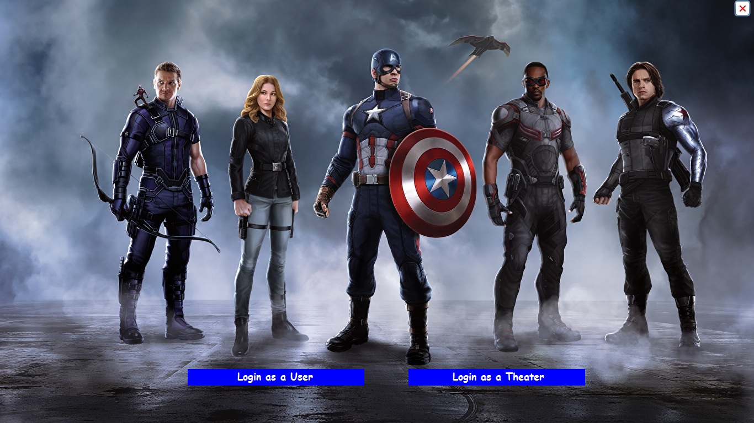

**Theatre Login Window:-**

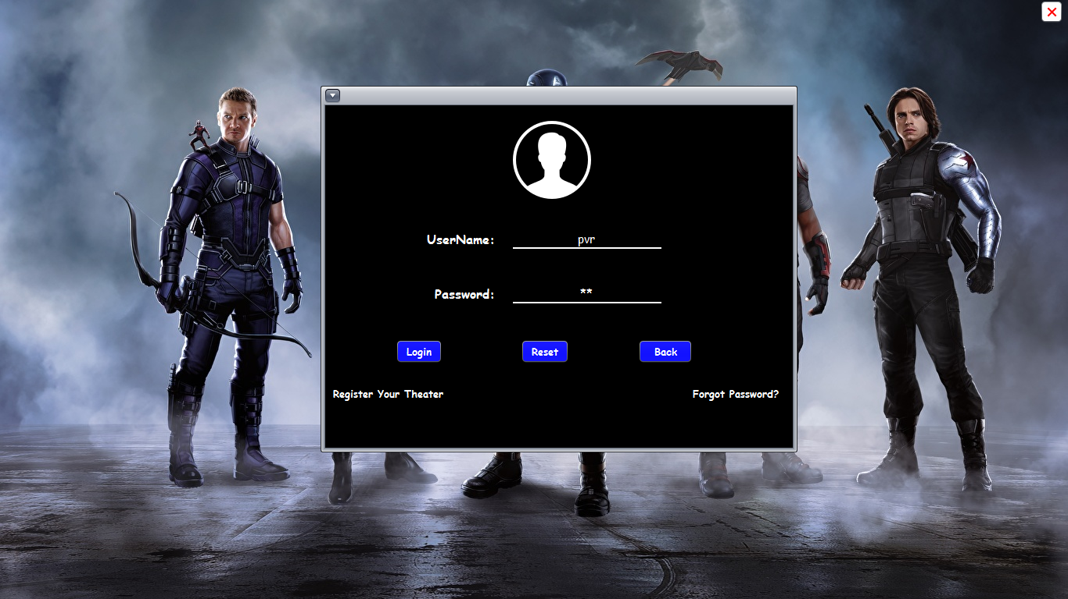

**Register Your Theatre:-**

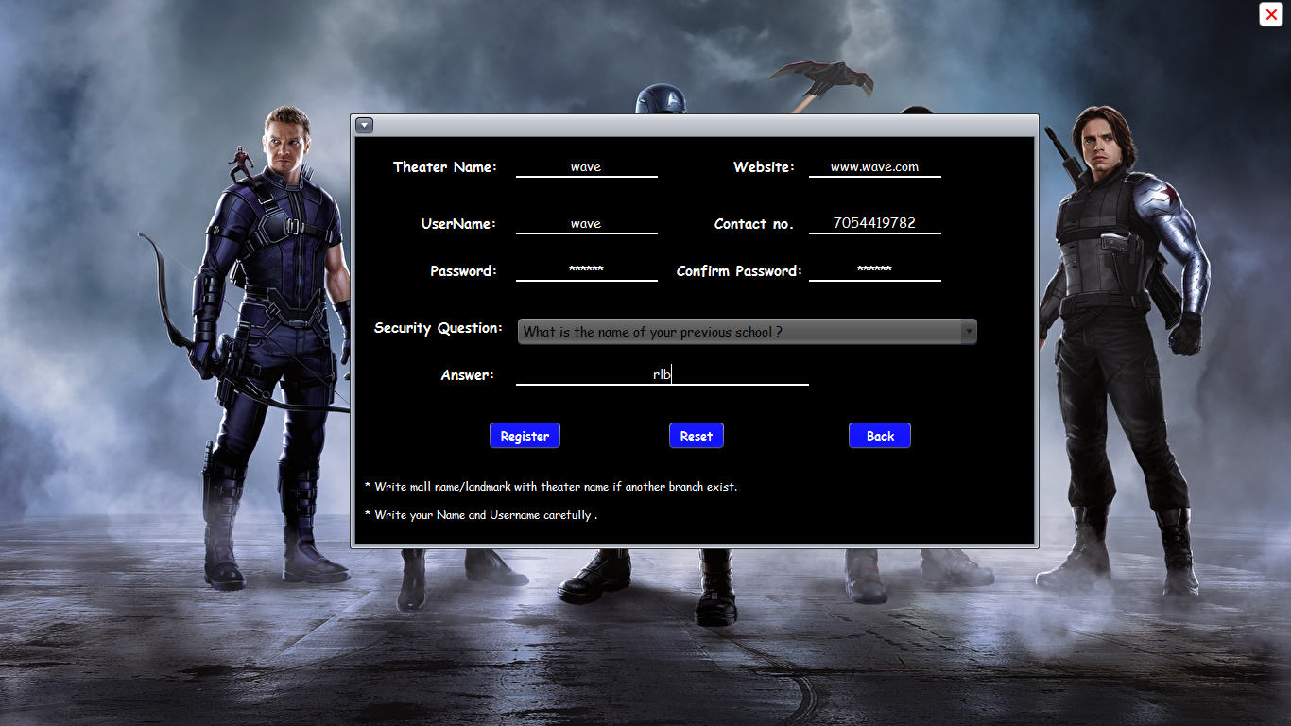

**Forgot Password:-**

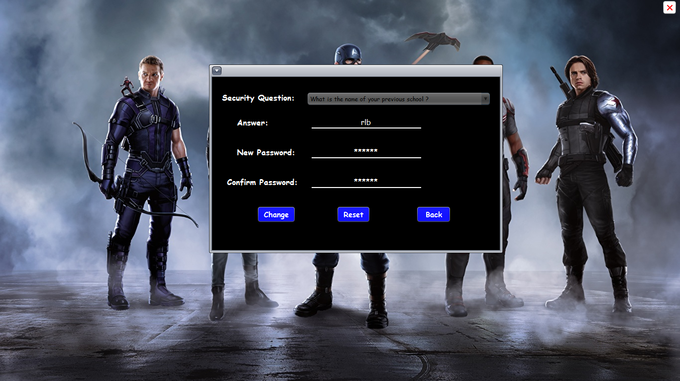

**Add a Show:-**

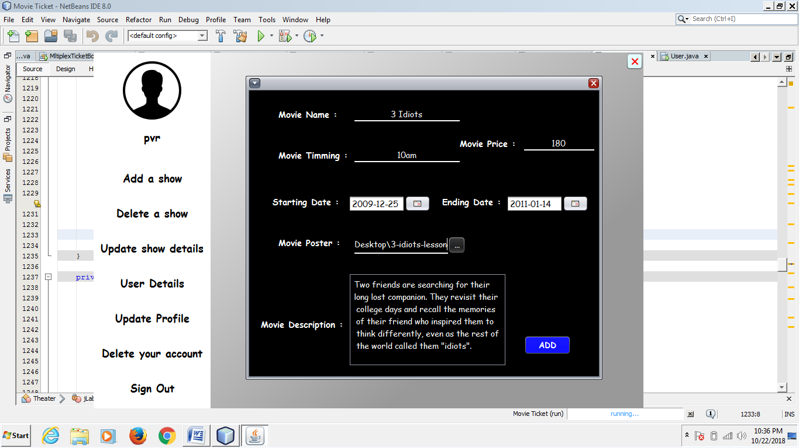

**Delete a Show:-**

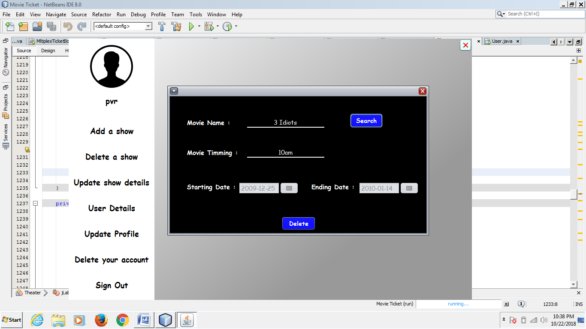

**Update Show Details:-**

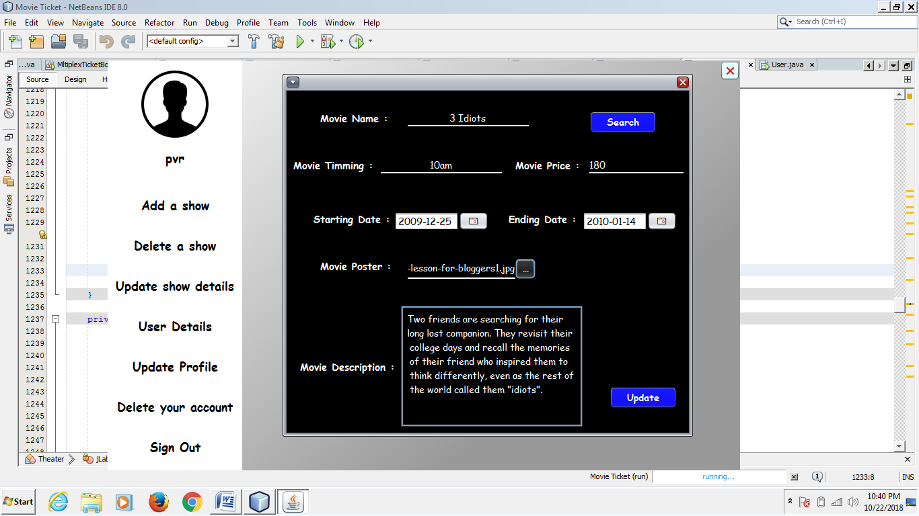

**User Details:-**

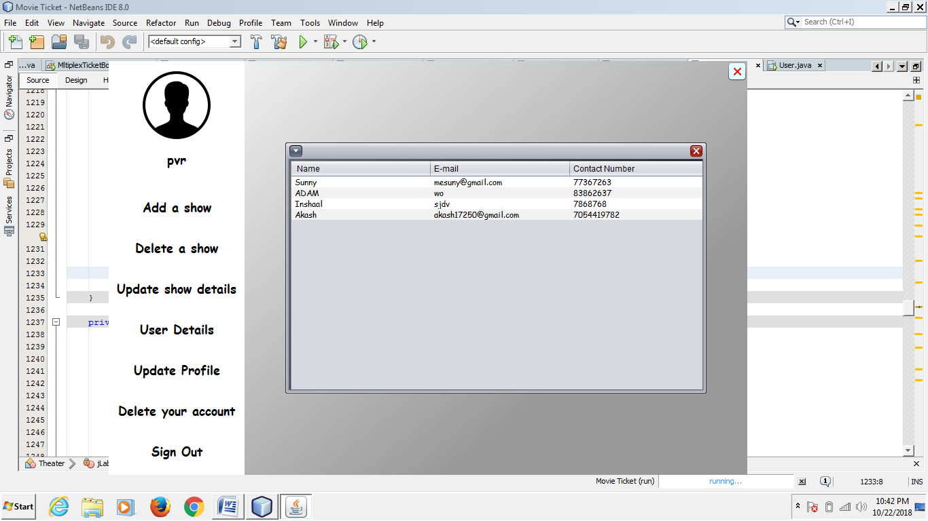

**Update Profile:-**

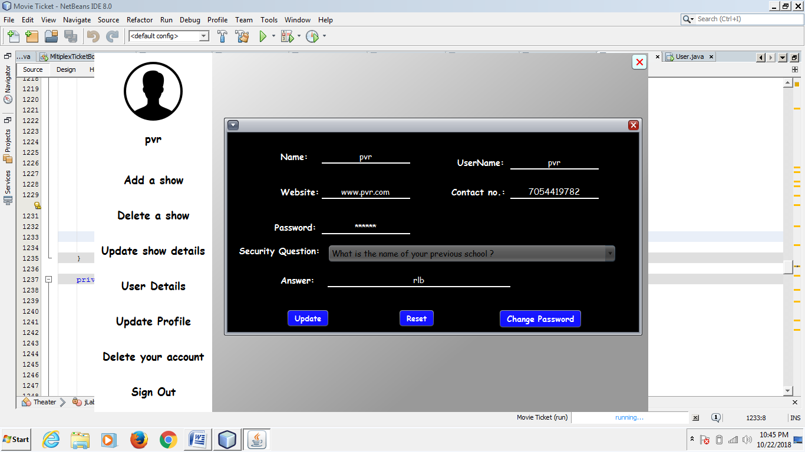

**Delete Your Account:-**

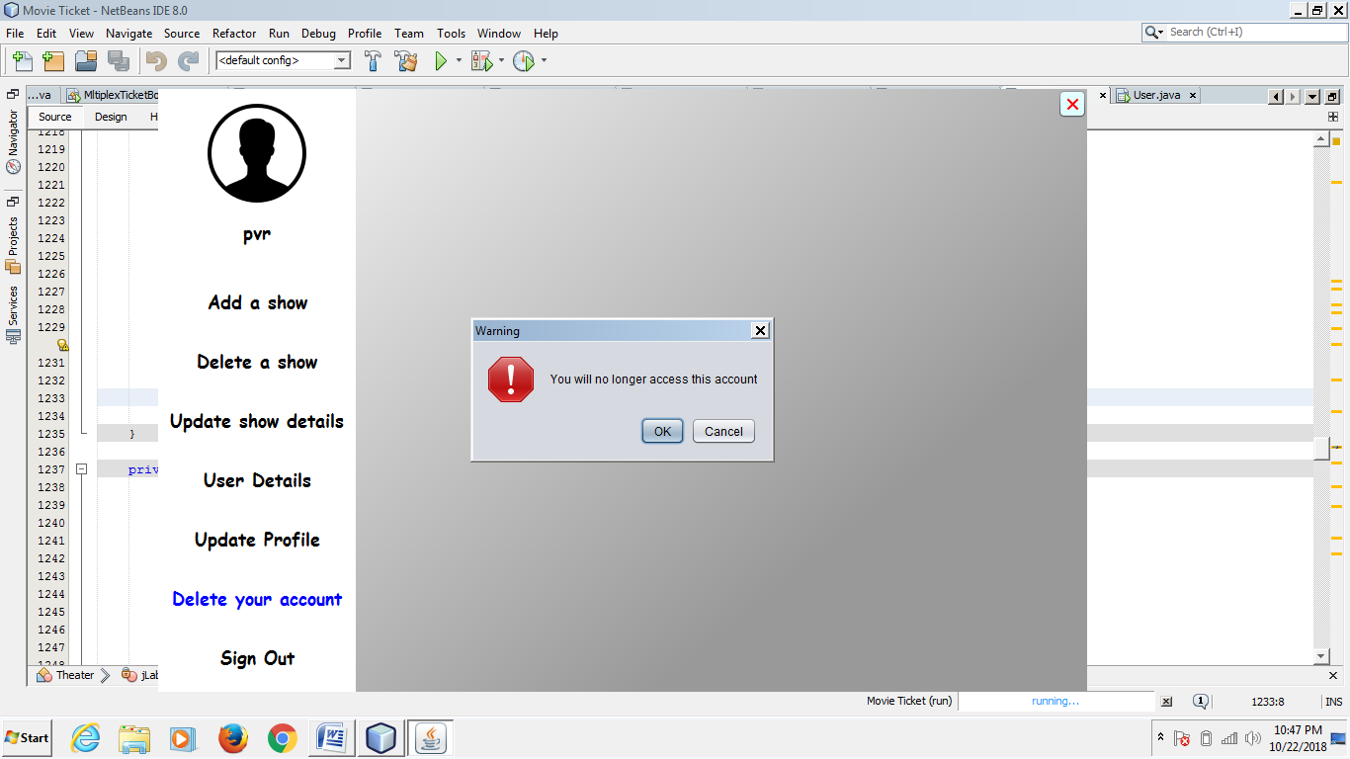

**Sign Out:-**

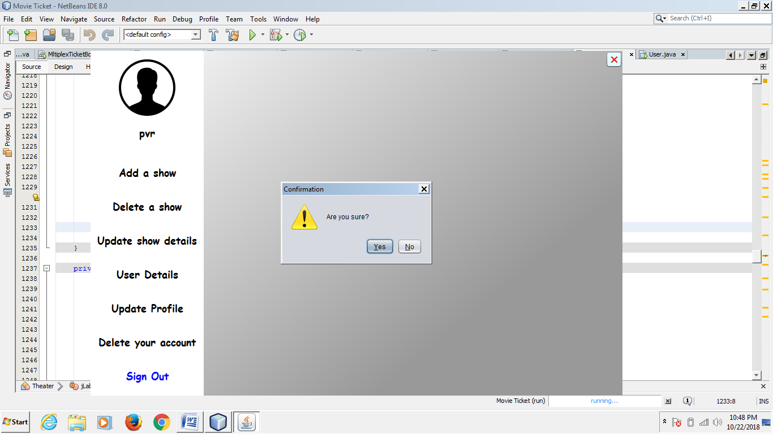

**User Login Window:-**

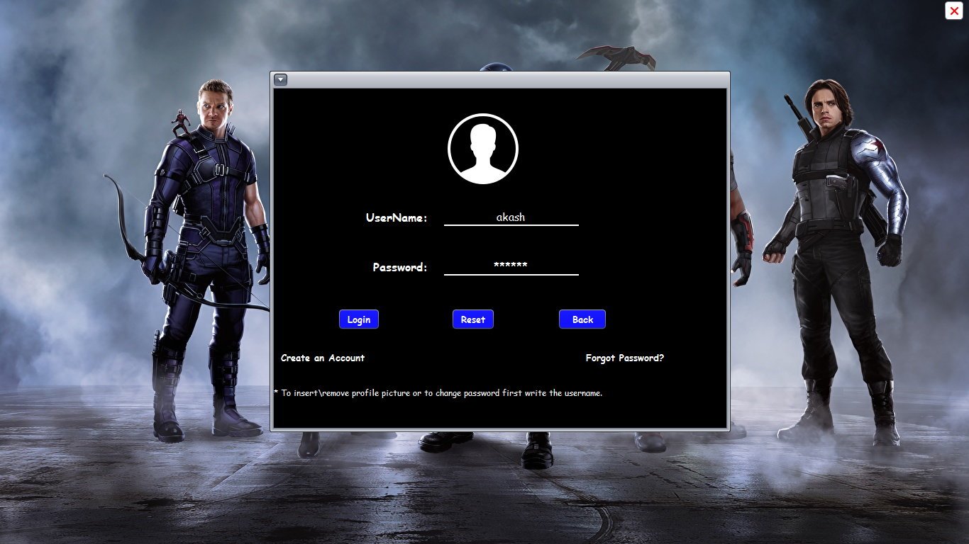

**Create An Account:-**

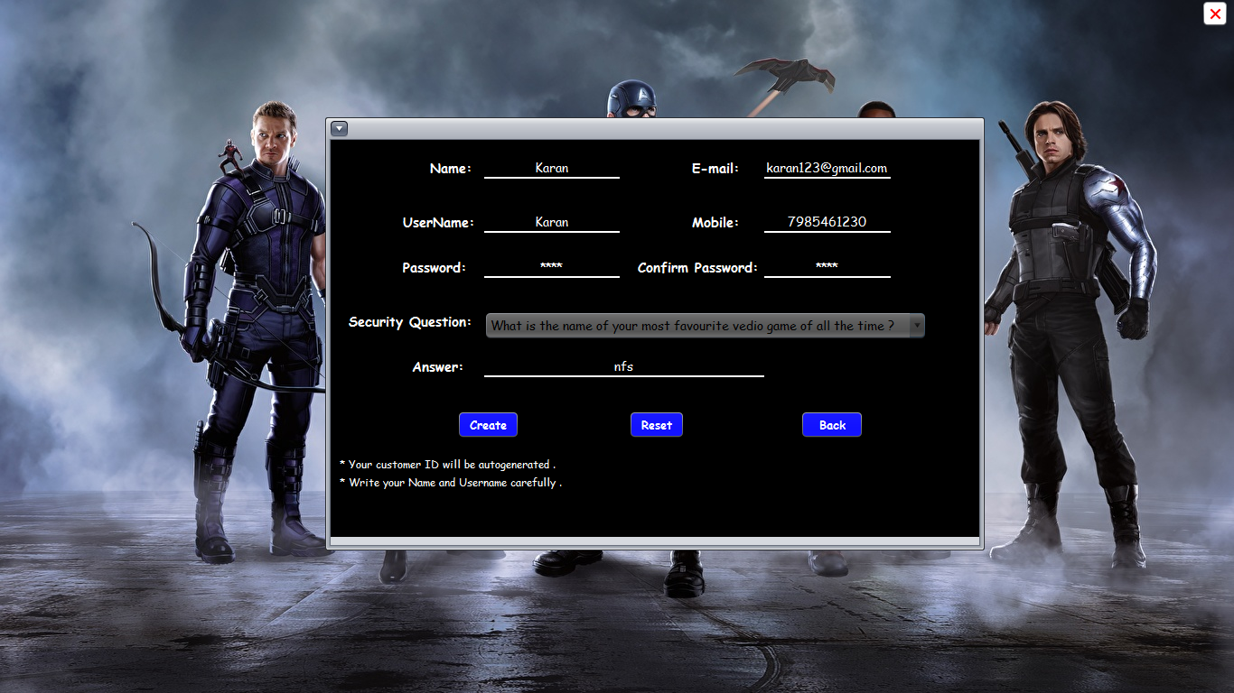

**Forgot Password:-**

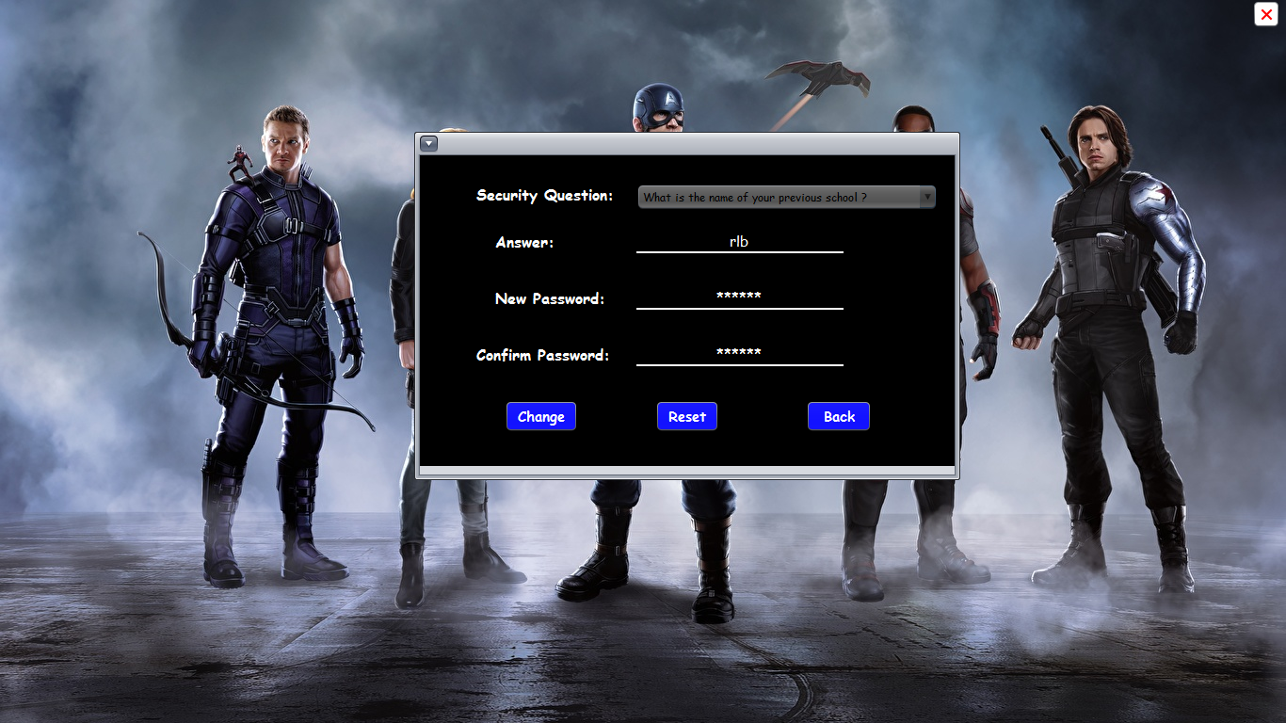

**Book a Ticket:-**

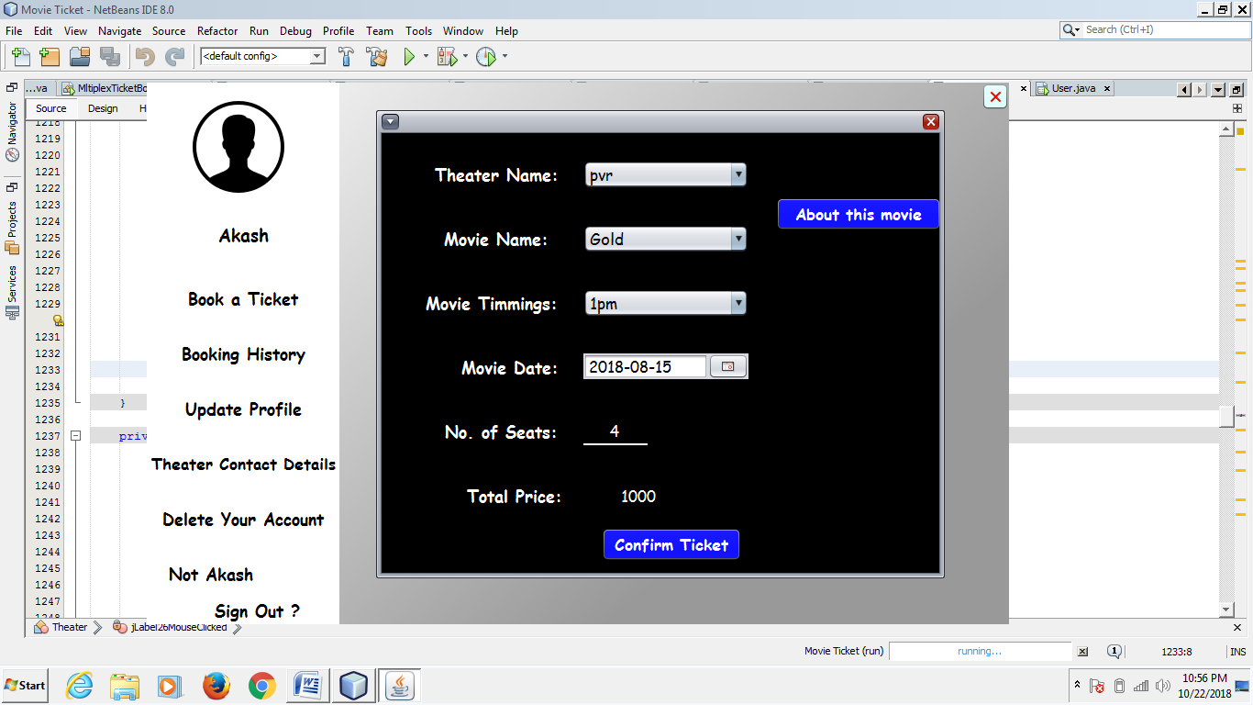

**About This Movie:-**

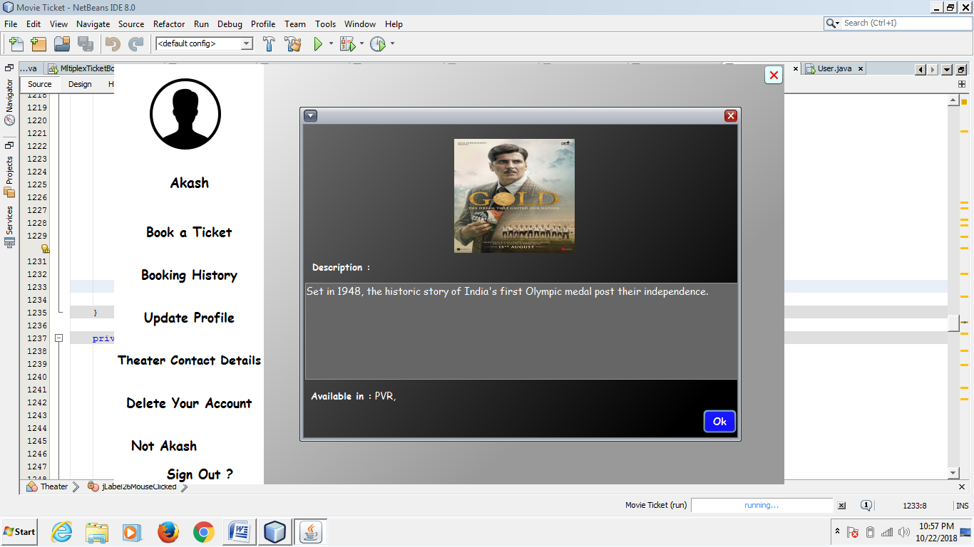

**Booking History:-**

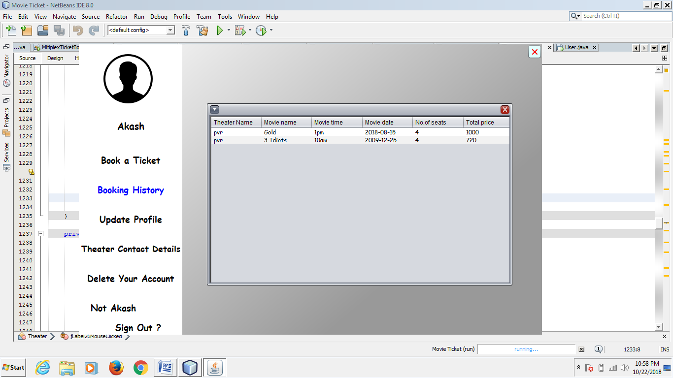

**Update Profile:-**

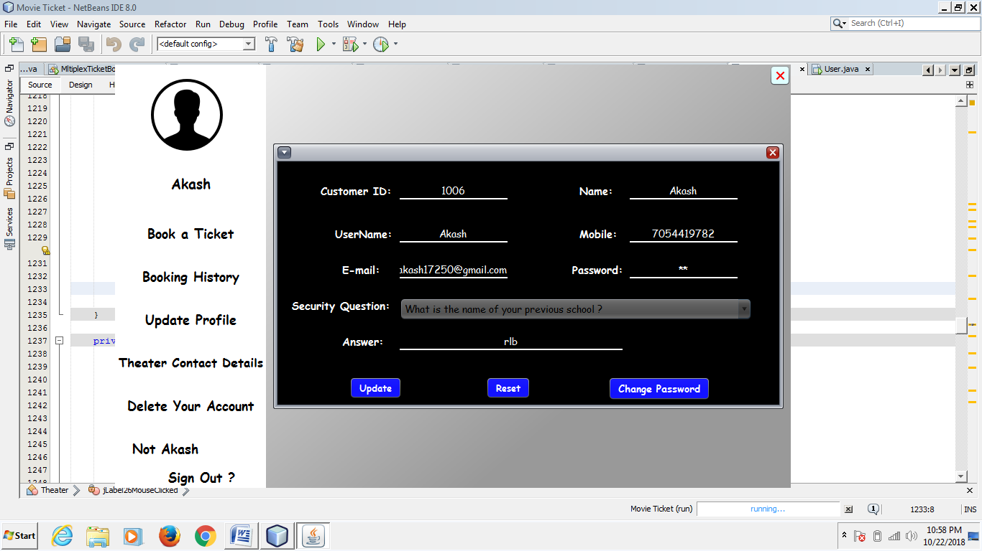

**Theatre Control Details:-**

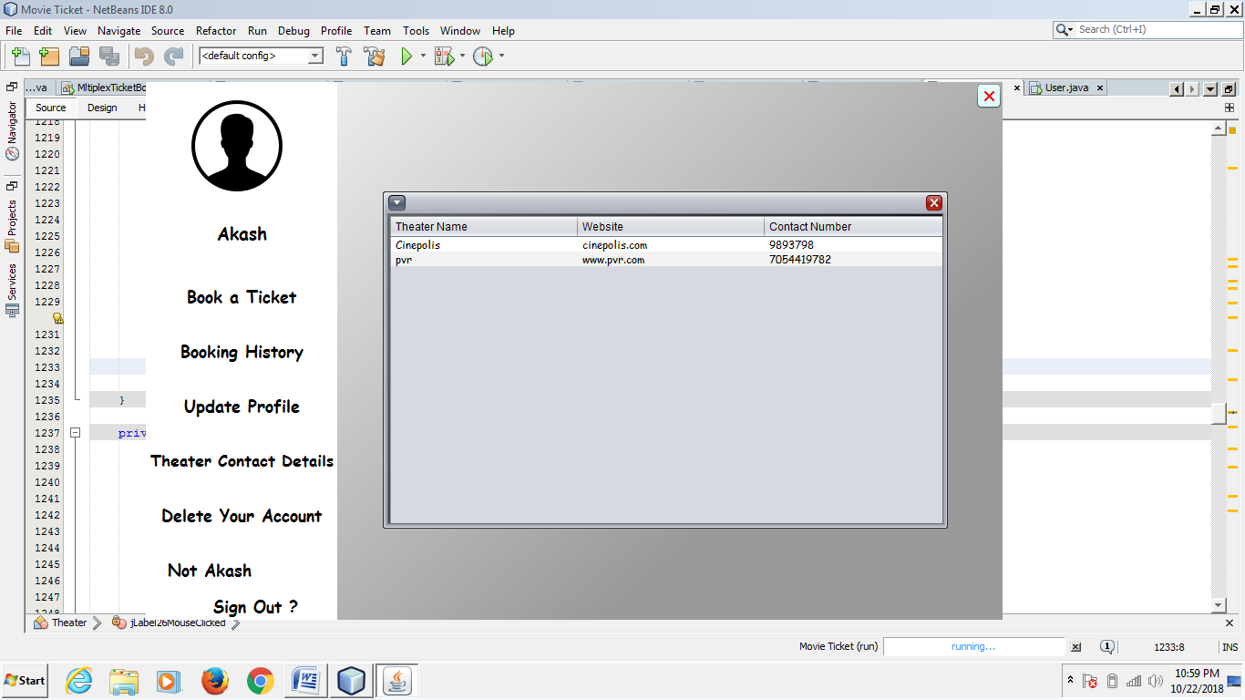

**Delete Your Account:-**

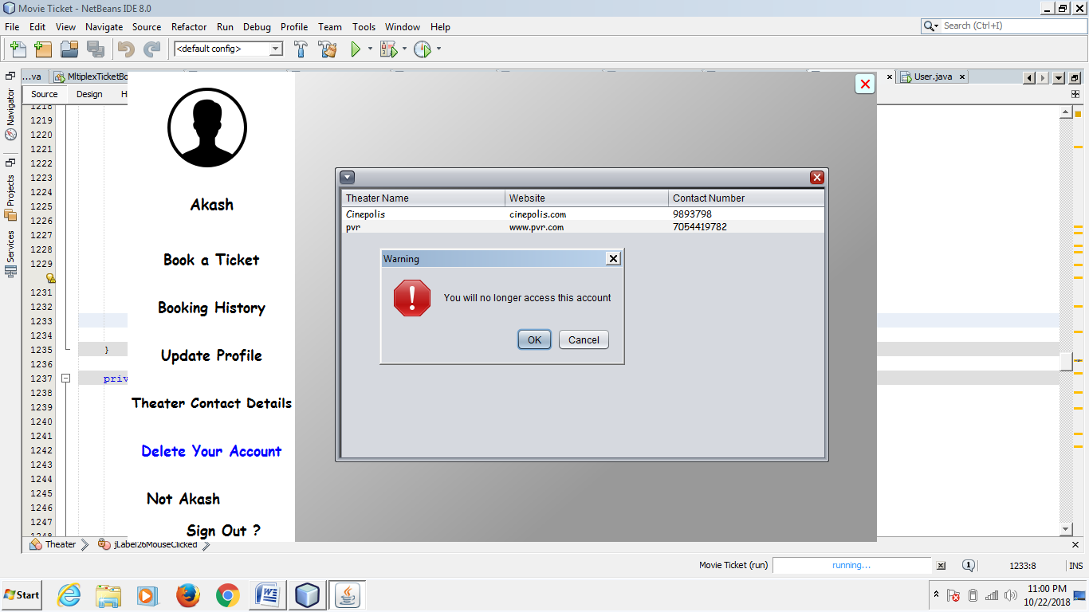

**Sign Out:-**

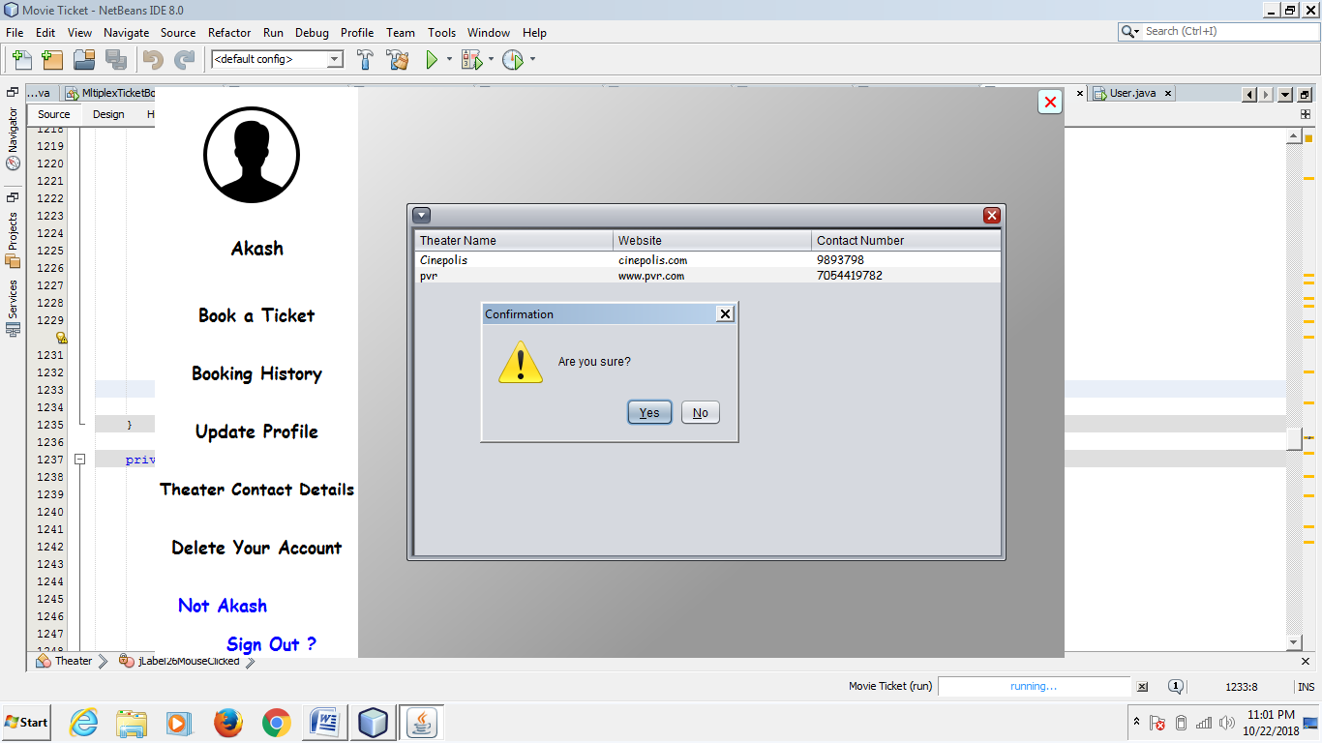

**3.6 TESTING**

**Testing:-**

**System Testing: -**

Black box testing method was used for system testing. The black box testing usually demonstrates that software functions are operational; that the input is properly accepted and the output is correctly produced; and that integrity of external information (databases) is maintained.

**Why testing is done:-**

* Testing is the process of running a system with the intention of finding errors.
* Testing enhances the integrity of a system by detecting deviations in design and errors in the system.
* Testing aims at detecting error-prone areas. This helps in the prevention of errors in a system.
* Testing also add value to the product by confirming to the user requirements.

**Causes of Errors:-**

The most common causes of errors in a software system are:

* **Communication gap between the developer and the business decisionmaker:** A communication gap between the developer and the business decision maker is normally due to subtle differences between them. The differences can be classified into five broad areas: Thought process, Background and Experience, Interest, Priorities, Language.
* **Time provided to a developer to complete the project:** A common source of errors in projects comes from time constraints in delivering a product. To keep to the schedule, features can be cut. To keep the features, the schedule can be slipped. Failing to adjust the feature set or schedule when problems are discovered can lead to rushed work and flawed systems.
* **Over Commitment by the developer:** High enthusiasm can lead to over commitment by the developer. In these situations, developers are usually unable to adhere to deadlines or quality due to lack of resources or required skills on

the team.

* **Insufficient testing and quality control:** Insufficient testing is also a major source of breakdown of e-commerce systems during operations, as testing must be done during all phases of development.
* **Inadequate requirements gathering:**  A short time to market results in developers starting work on the Web site development without truly understanding the business and technical requirements. Also, developers may create client-side scripts using language that may not work on some client browsers.
* **Keeping pace with the fast changing Technology:** New technologies are constantly introduced. There may not be adequate time to develop expertise in the new technologies. This is a problem for two reasons. First, the technology may not be properly implemented. Second, the technology may not integrate well with the existing environment.

**Testing Principles:-**

* To discover as yet undiscovered errors.
* All tests should be traceable to customer’s requirement.
* Tests should be planned long before the testing actually begins.
* Testing should begin “in the small” & progress towards “testing in the large”.
* Exhaustive Testing is not possible.
* To be most effective training should be conducted by an Independent Third Party

**Testing Objectives:-**

* Testing is a process of executing a program with the intent of finding errors.
* A good test case is one that has a high probability of finding an as yet undiscovered error.
* A successful test is one that uncovers an as yet undiscovered error.

**Kinds of Testing:-**

**Black Box Testing- Not** based on any knowledge of internal designs or code. Tests are based on requirements and functionality.

**White Box Testing-** Based on the knowledge of the internal logic of an application’s code. Tests are based on coverage of code statements, branches, paths and statements.

**Unit Testing-** The most ‘micro’ scale of testing; to test particular functions and code modules. Typically done by the programmer and not by the testers, as it requires detailed knowledge of the internal program design and code. Not always easily done unless the application has a well-designed architecture with tight code; may require developing test driver modules or test harnesses.

**Integration Testing-** Testing of combined parts of an application to determine if they function together correctly. The ‘parts’ can be code modules, individual applications, client and server applications on a network, etc. This type of testing is especially relevant to client/ server and distributed systems.

**Functional Testing-** Black-box type testing geared to functional requirements of an application; testers should do this type of testing. This doesn’t mean that the programmers shouldn’t check that their code works before releasing it.

**Regression Testing-** Re-testing after fixes or modifications of the software or its environment. It is difficult to determine how much re testing is needed, especially near the end of the development cycle. Automated testing tools can be especially useful for this type of testing.

**Acceptance Testing-** Final testing based on the specifications of the end user or customer or based on use by end-users/ customers over some limited period of time.

**User Acceptance Testing-** Determining if software is satisfactory to an end user customer

**Testing Technique Used:-**

We will continuously test our project to insure that it is fully functional. In order to perform testing test cases are designed with the intent of finding the errors in the project and help in removing those errors. Testing begins at the module level and is conducted systematically. It is generally conducted by independent test groups or third party.

Testing is done in our project CINE TICKET PRO System with help of black box testing that exercise all the functional requirement of the project test cases are designed using this approaches by providing set of input conditions to get the expected output.

**Test Cases Designed**

**TEST CASES FOR CLIENT:-**

|  |  |  |  |
| --- | --- | --- | --- |
| **TEST CASE ID** | **INPUT** | **EXPECTED OUTPUT** | **ACTUAL OUTPUT** |
| 1 | Password and key combination | Start | Operation started |
| 2 | No Input | Alert Message | Select a valid configuration setting |

**TEST CASES FOR SERVER:-**

|  |  |  |  |
| --- | --- | --- | --- |
| **TEST CASE ID** | **INPUT** | **EXPECTED OUTPUT** | **ACTUAL OUTPUT** |
| 1 | 127.0.0.1 | Connection establish | Client Connected |
| 2 | Get Status | Alert Box | If no client selected “alert box” is displayed |
| 3 | Choose Path | Transfer files to valid path | Files transferred |

**3.7 IMPLEMENTATION**

**Implementtation:-**

**System Implementation:-**

During the implementation stage the system in physically created. Necessary programs are coded, debugged and documented. A new hardware is selected, ordered and installed.

**System Specification:-**

Every computer system consists of three major elements.

1. The Hardware
2. Application software such as visual studio
3. Operating system

For successful operation of the package following must be kept in mind:

Too many packages should not be used, as very few systems may have all those packages installed due to memory problem. Thus, the compatibility of the system development will get reduced.

**3.8 FUTURE SCOPE OF PROJECT**

**Future Scop Of Project:-**

The proposed system helps them in many ways. It helps them do billing very easily. Account maintenance also becomes easier. They can keep track of their all movie details and customer account details. The software is provided with all the master entries to enter any new movies or to add or modify and delete the movie shows and timings.

As this is generic software it can be used by a wide variety of multiplex cinema halls to automate the process of manually maintaining the records related to the subject of maintaining the movie details and customer data.

In future it can be modify, so that it can be done online.

**3.9 CONCLUSION**

**Conclusion:-**

This section discuses the result of work done in this project and also mentions the future scope improvement.

The software will be developed by implementing the concept of modularity which in turn reduces the complexity involved in maintaining it. The administrator should have a sound technical knowledge about maintaining the software and further enhancements will be undertaken by the developer.

The application is portable which ensure its adaptability for use on different computer terminals with different operating system and standards.

The factors guarantee the software’s availability includes proper termination and correct input details. Also the resources used for the project development are Microsoft certified which speaks of its high quality standards.

Hence we may conclude that the application system being developed helps a great deal in modifying the computerized CINE TICKET PRO SYSTEM.

**4.BIBLIOGRAPHY**

**Book Refrences:-**

The following books were referred during the analysis and execution phase of the project

**Common Language Runtime**

-By Steven Pratschner

**SOFTWARE ENGINEERING**

-By Roger S. Pressman

**UNIFIED MODELING LANGUAGE**

-By Gradi Booch, Ivar Jacobson,

James Rambaugh

**COMPLETE REFERENCE .NET**

-By David S Platt

**MSDN 2003**

-By Microsoft

**IMAGES**

Bing Search

Msn Search

Google Search

**HTML PUBLISHING BIBL**

- Alan Simpson.

**C# 2008**

-Andrew Troelson

**Designing and implementation phase: -**

1. Software engineering: a practitioners approach by roger s pressman.
2. System analysis and design by Elias m. Ewad.
3. DBMS : Bipin C Desai
4. Introduction to dbms – shailendrasharma
5. Modern database management -drkumar
6. Fundamentals of database systems- ramezelmsari
7. An intro to dbms- christhopher j date
8. Database system concepts-abrahamsilbersch
9. Database management systems-raghuramkrishnan
10. Principles of database systems- jd Ullman
11. Foundation of databases- sergebabiteboul
12. Database systems-connolly

**WEBSITES:-**

* [**www.google.com**](http://www.google.com)
* [**www.netbeans.com**](http://www.netbeans.com)
* [**www.sql.com**](http://www.sql.com)
* [**www.wikipidia.com**](http://www.wikipidia.com)
* [**www.ask.com**](http://www.ask.com)
* [**www.sitebay.com**](http://www.sitebay.com)
* <https://www.freeprojectz.com/dfd/online-movie-ticket-booking-system-dataflow-diagram>
* <https://www.slideshare.net/mrinnovater007/online-movie-ticket-booking-11583340>
* [www.w3school. com](http://www.w3school.microsoft.com)
* [www.projectcode.com](http://www.projectcode.com)
* [www.projectwork.com](http://www.projectwork.com)
* [www.github.com](http://www.github.com)
* [www.pcode.com](http://www.pcode.com)
* [www.oncode.com](http://www.oncode.com)
* [www.read](http://www.read) to learn.com
* www.coding.com